AP Physics C Index
 |  | M1 |  |  | M2 |  | M3 |  |  |  | E1 |  | E2 |  | E3
1  9  7  9 | s  o  l  n | 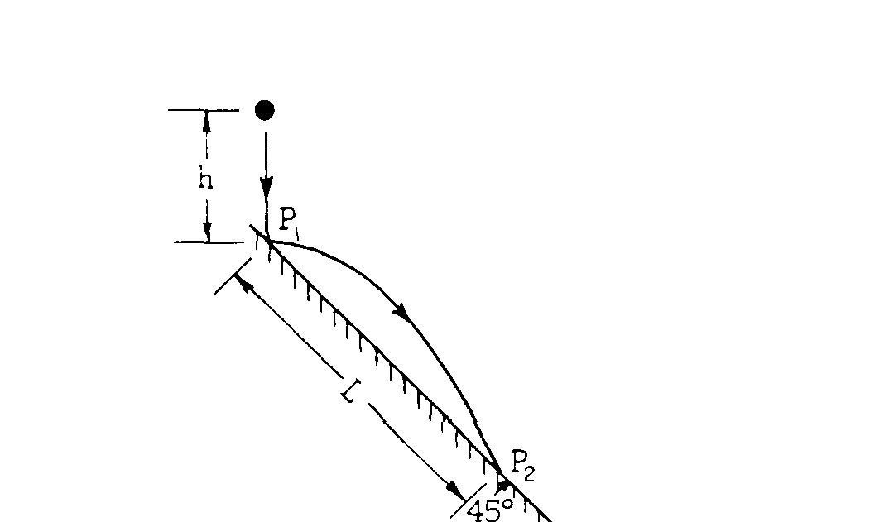  1979 - Projectile, en cons, mom cons. |  |  | 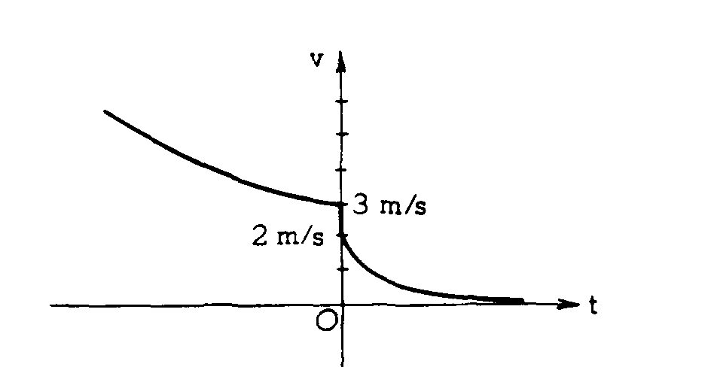  Ferry, cons of momentum, impulse |  | 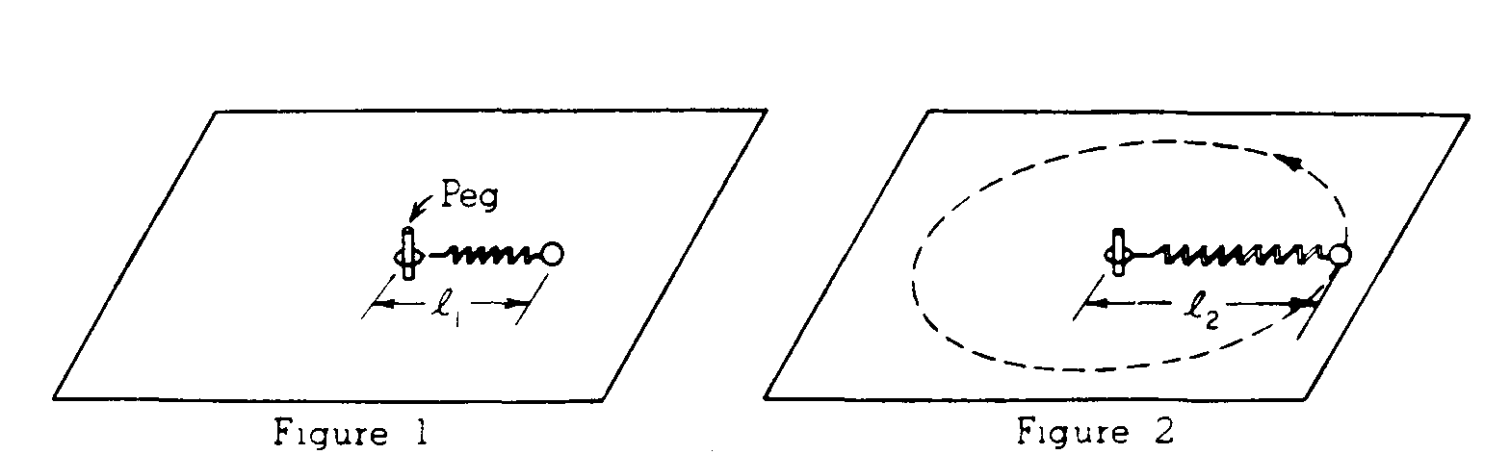  torque, ang mom, SHM w spring during rotation |  |  |  | 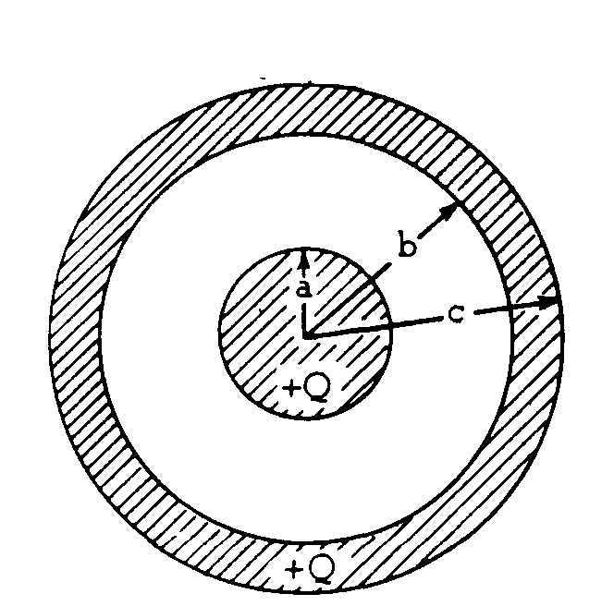  conc shells, Gauss’ law, E vs r, V vs r |  | 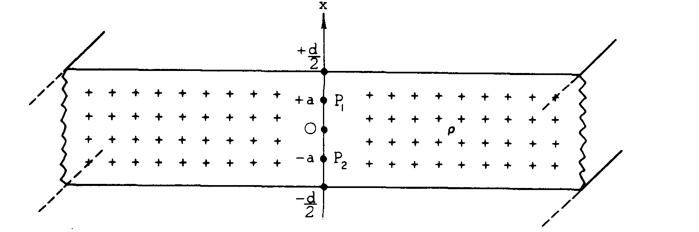  non-cond slab, E field, cond slab, B field. |  | 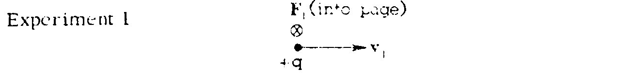  B fields and forces on particles. hand rules.
1  9  8  0 | s  o  l  n | 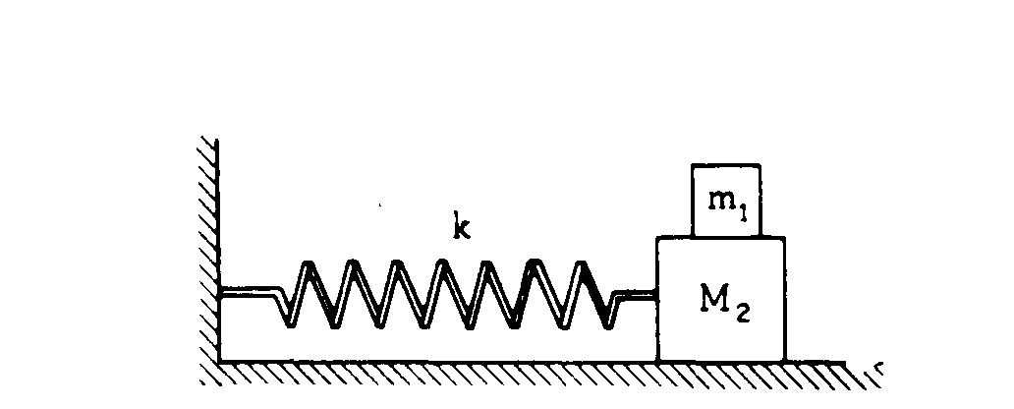  1980 - spring, SHM |  |  | 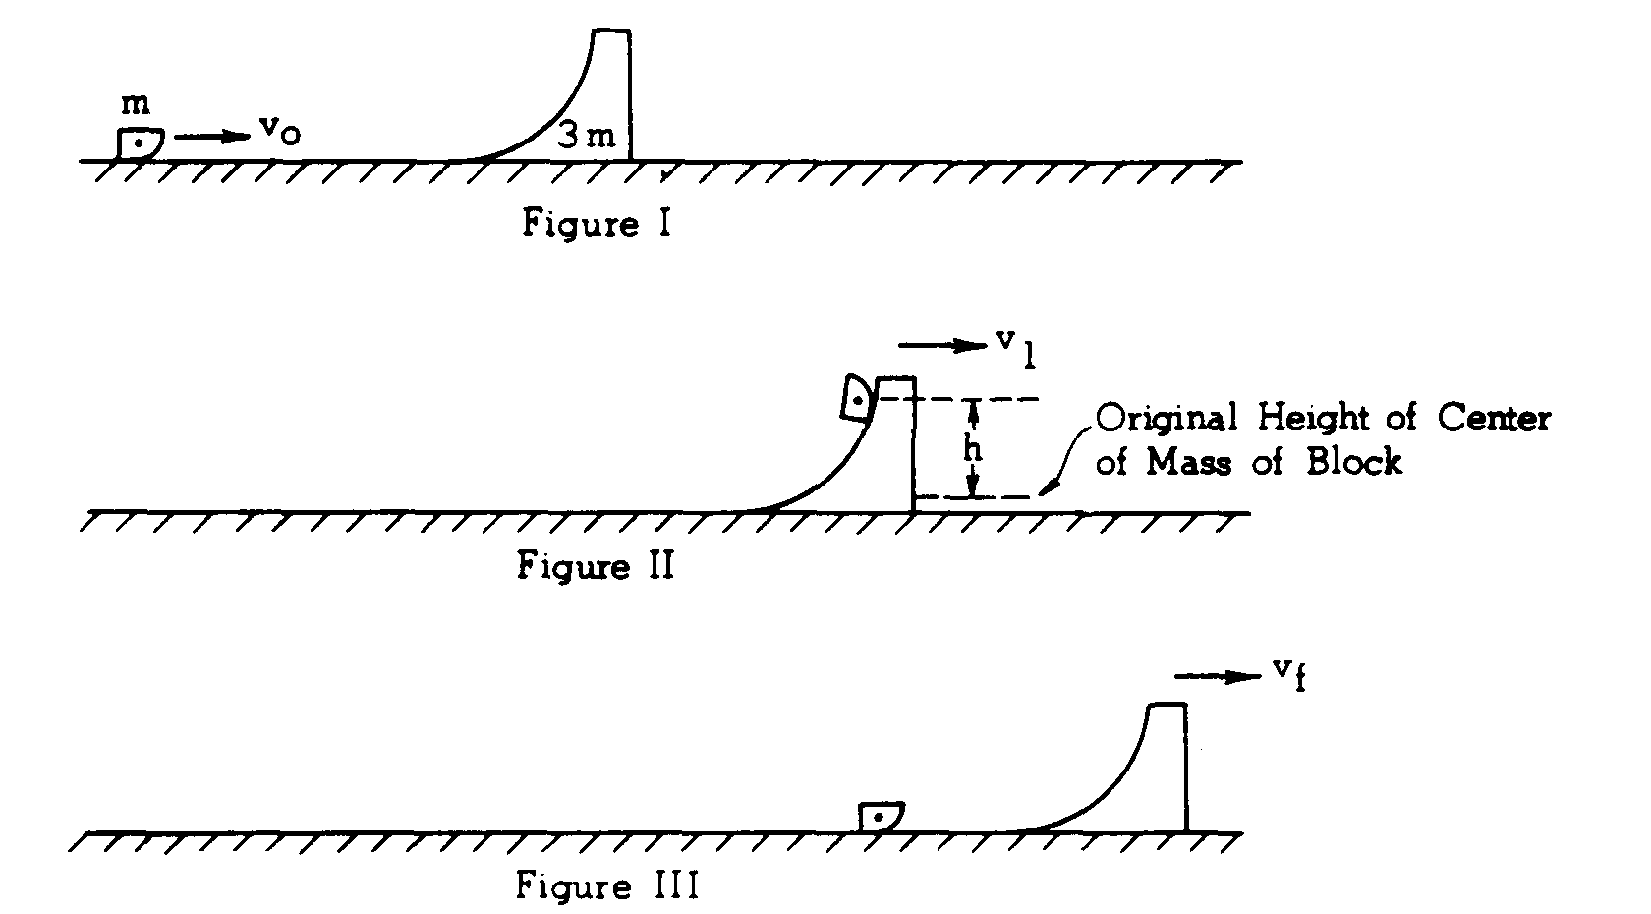  Momentum & En Conservation |  | 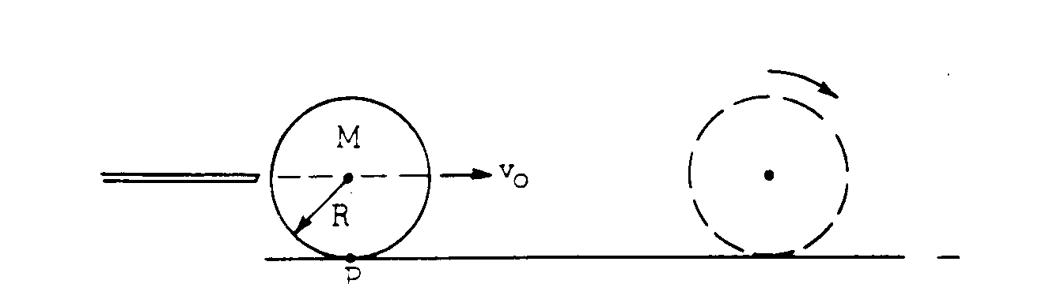  - Rotation w/o slipping, eqns of motion |  |  |  | 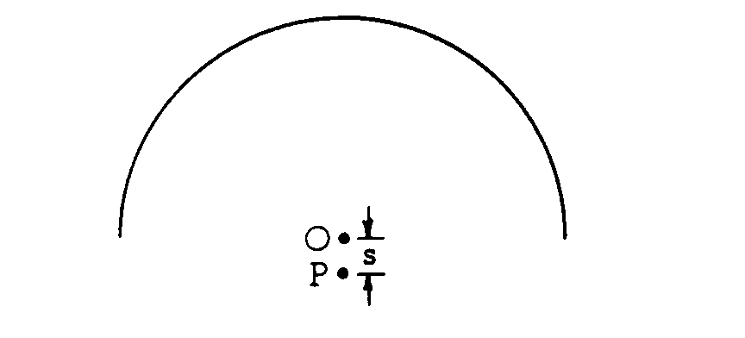  E and V for thin, bent rod. |  | 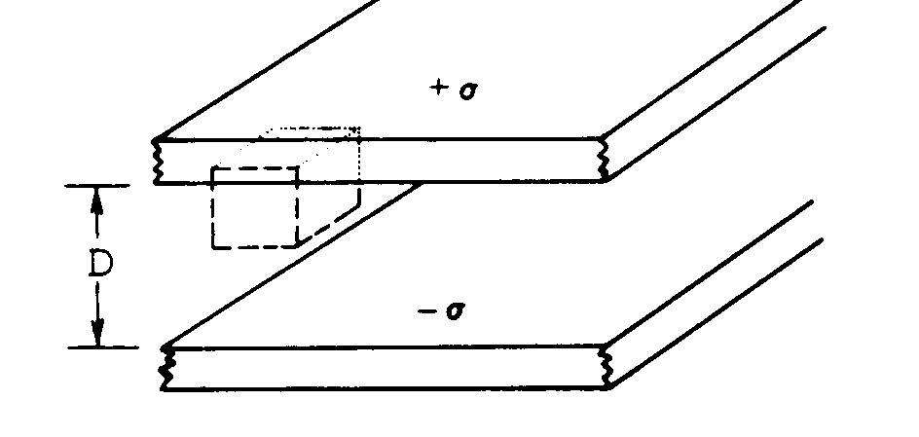  - Gauss’ Law E between plates, Capacitance |  | 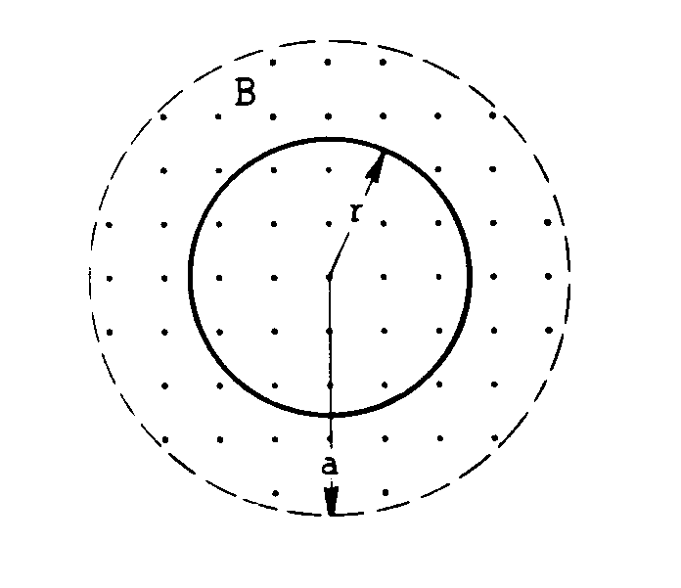  - Faraday’s Law, induced Emf and E
1  9  8  1 | s  o  l  n | 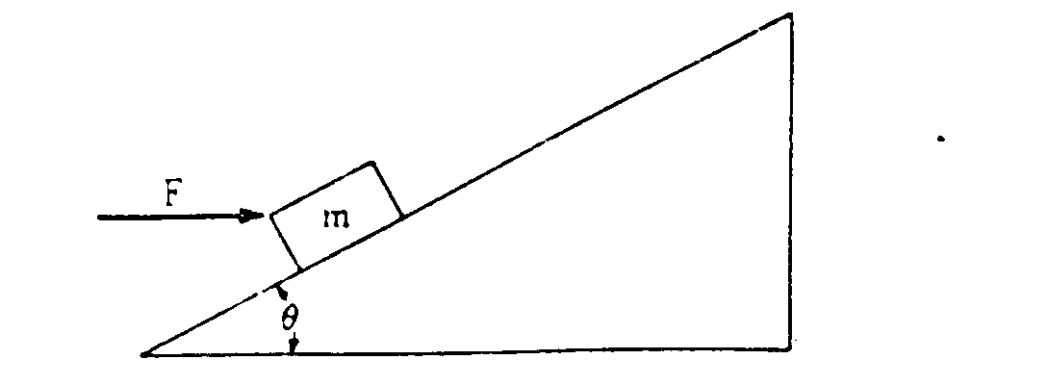  1981 - Incline, trans eq, friction |  |  | 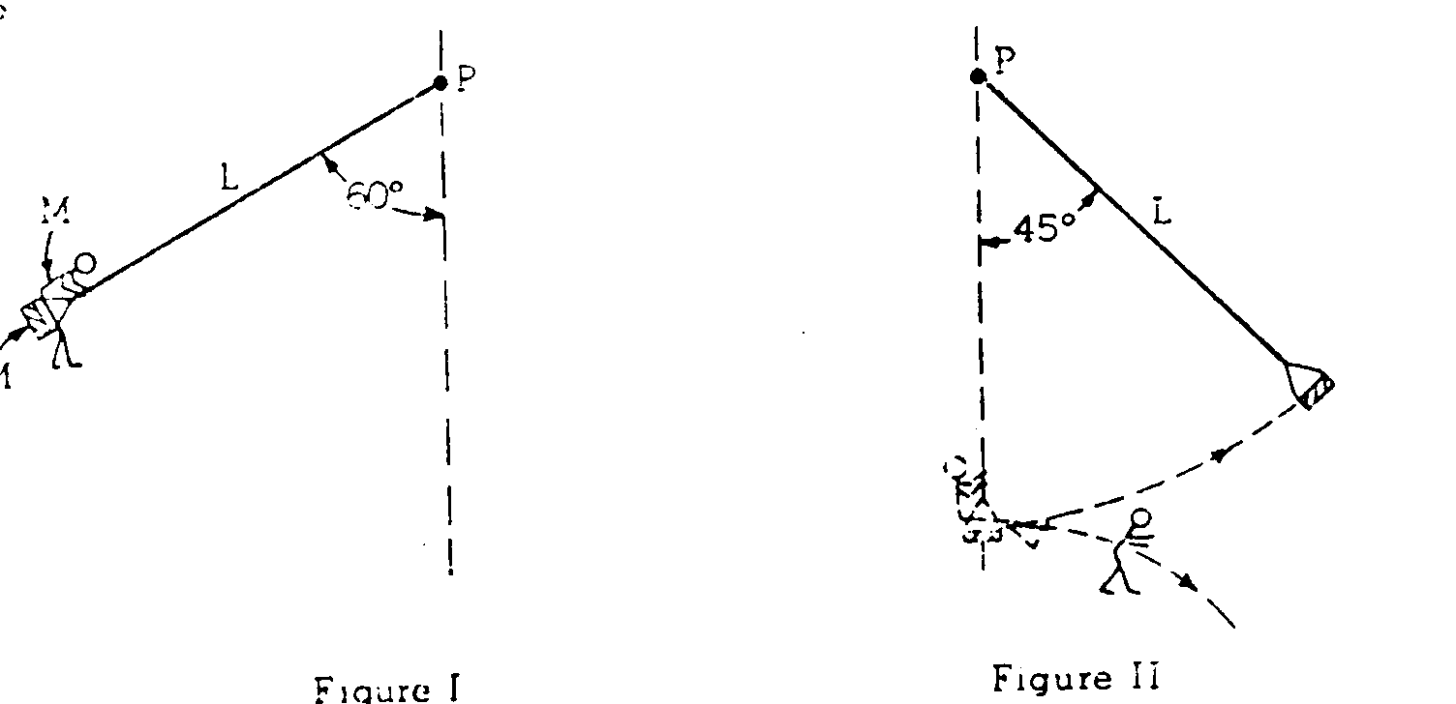  Energy on a swing |  | 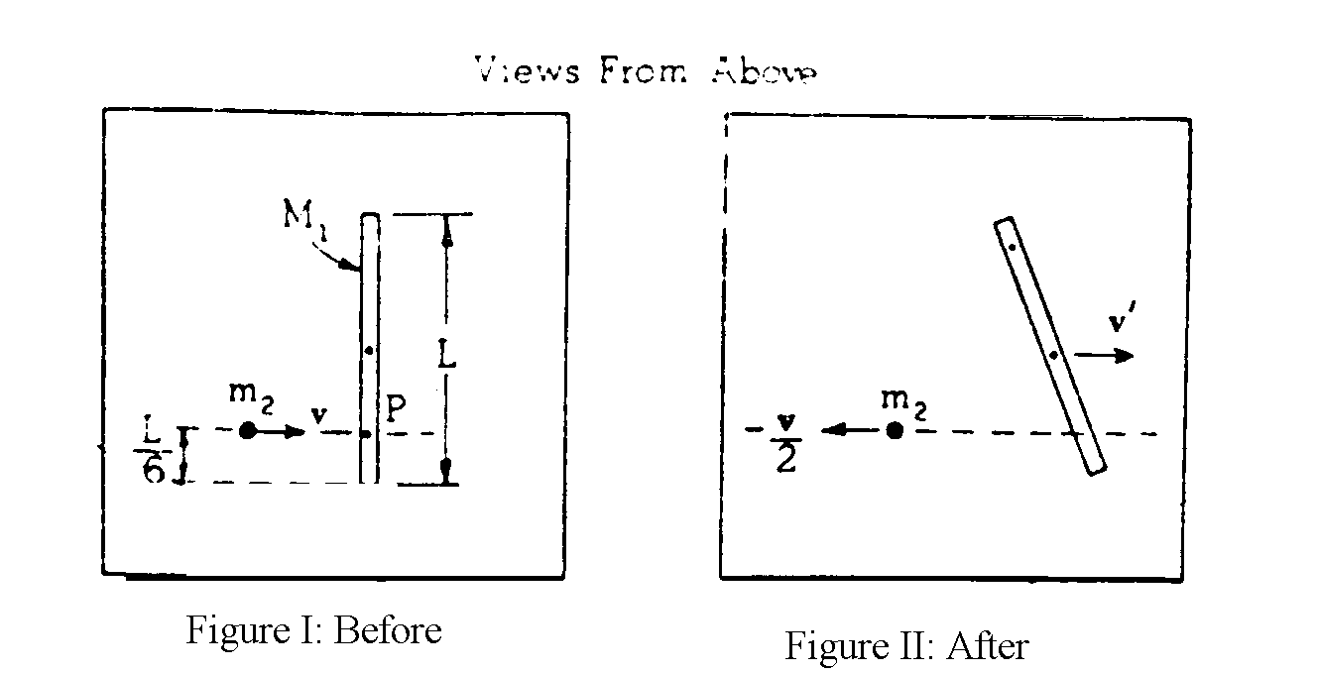  Cons of linear and ang momentum. |  |  |  | 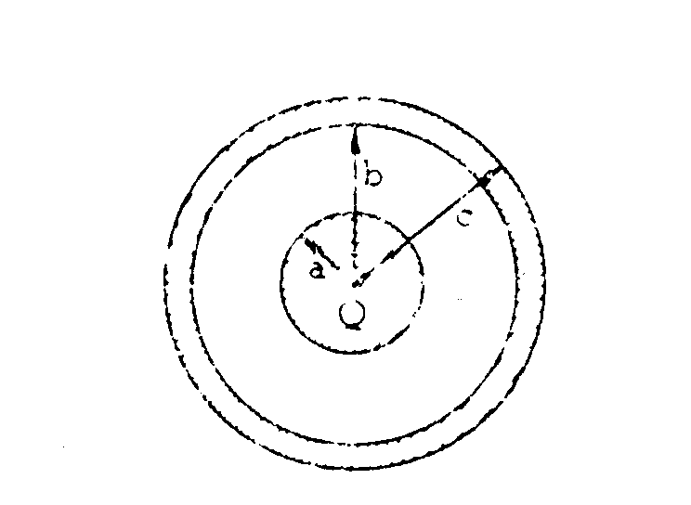  Gauss’ Law, spherical capac., dielectrics |  | 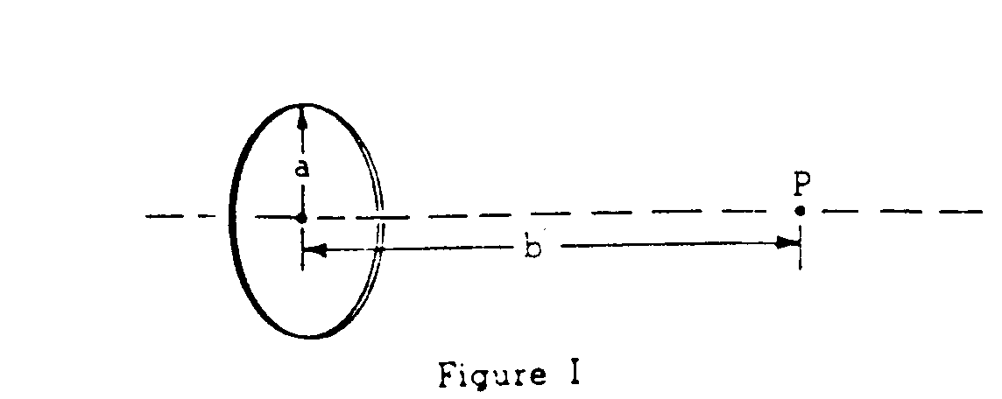  Elec and B field of a ring of charge |  | 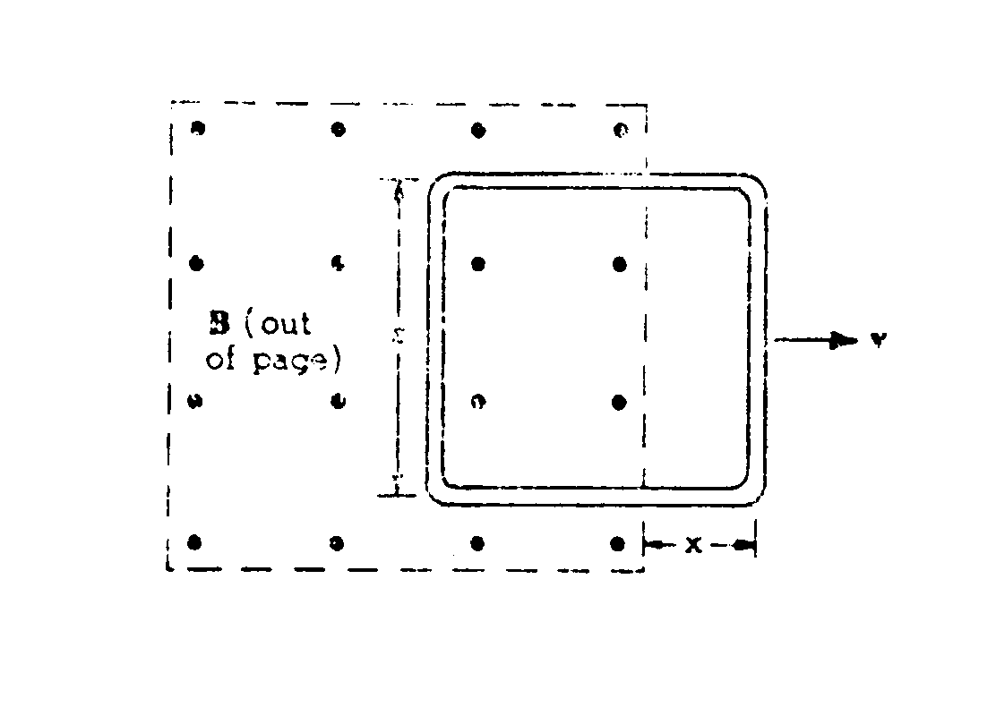  Faradays Law, induced Emf, I, power
1  9  8  2 | s  o  l  n | 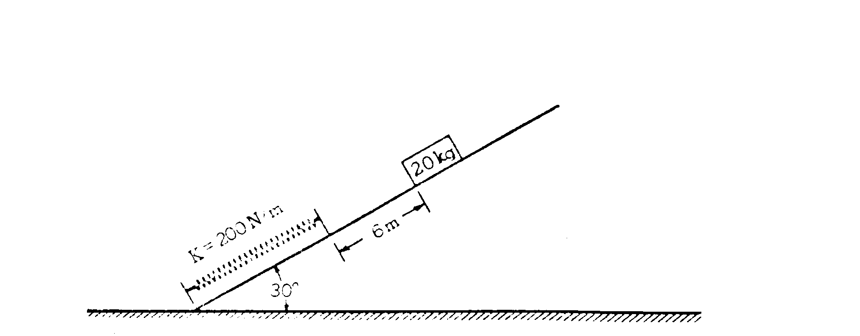  1982 - spring on incline, En cons |  |  | one dimensional motion of car with friction, slowing. |  | 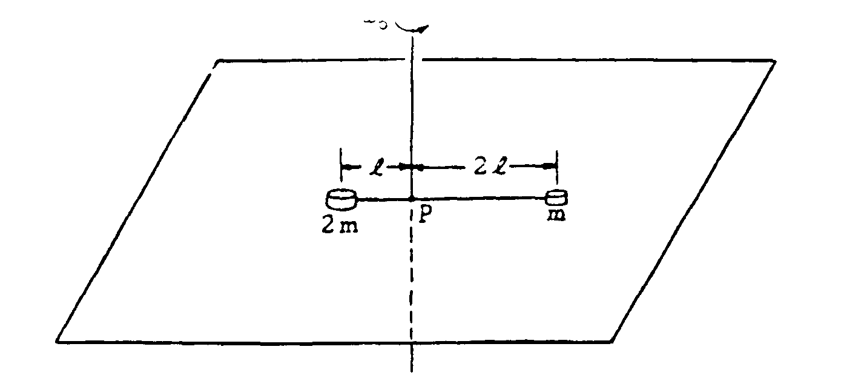  torque, I, rotation equations |  |  |  | 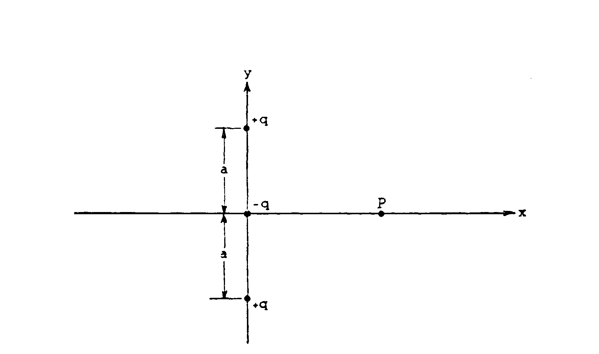  point charge, field, potential, flux |  | 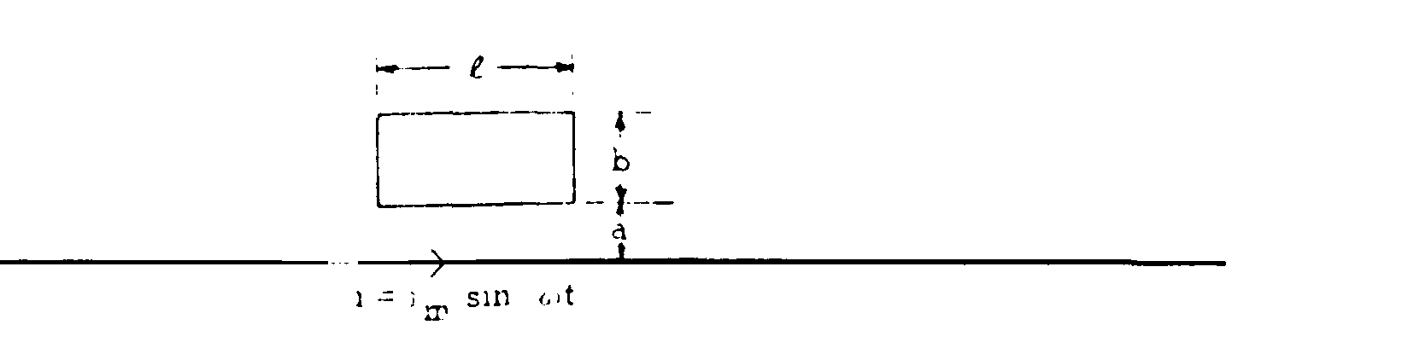  B for long wire, flux thru loop nearby |  | 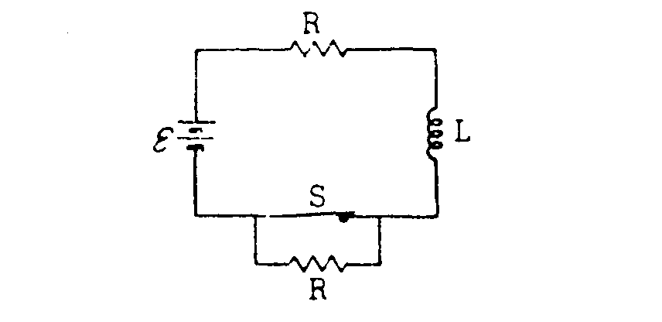  R-L circuit
1  9  8  3 | s  o  l  n | 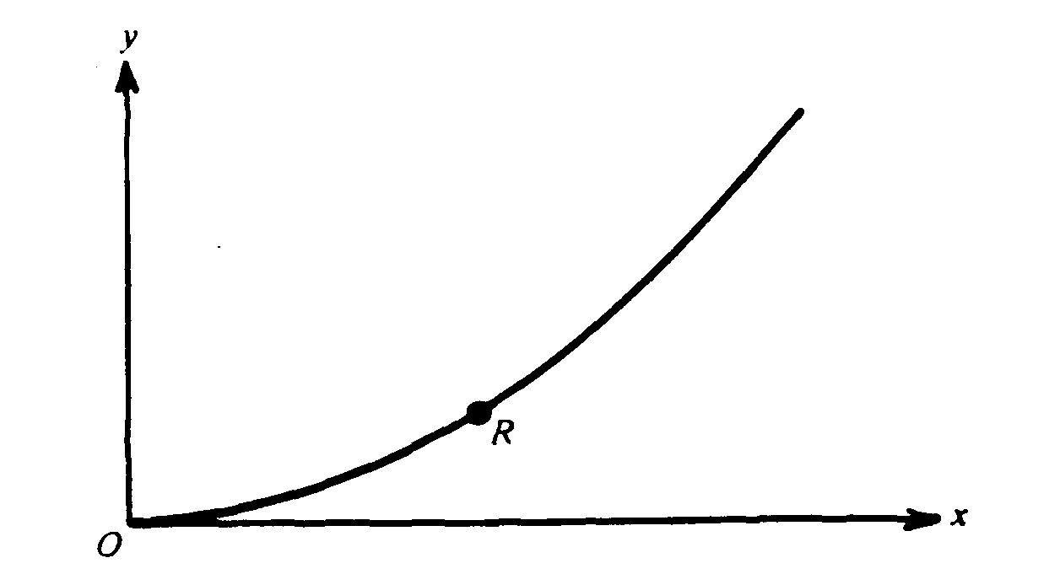  1983 - proj motion in a plane |  |  | 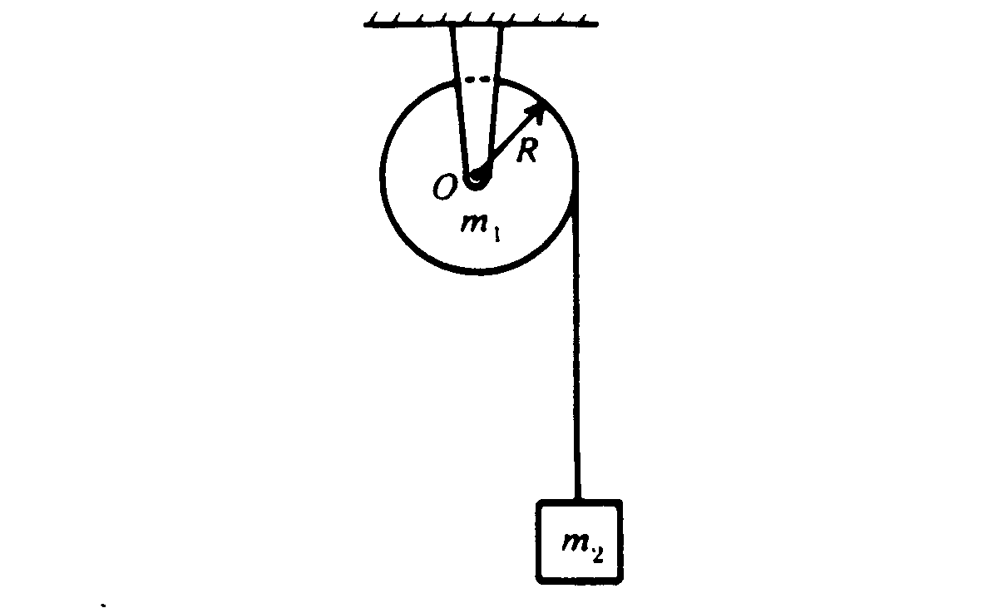  rotation, acceleration |  | 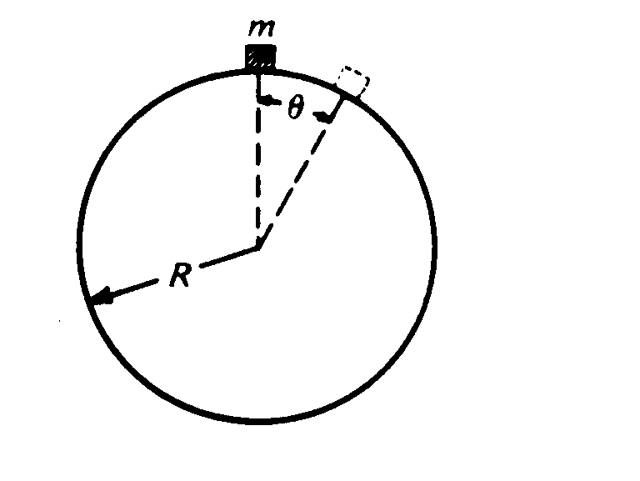  skier on snowball |  |  |  | 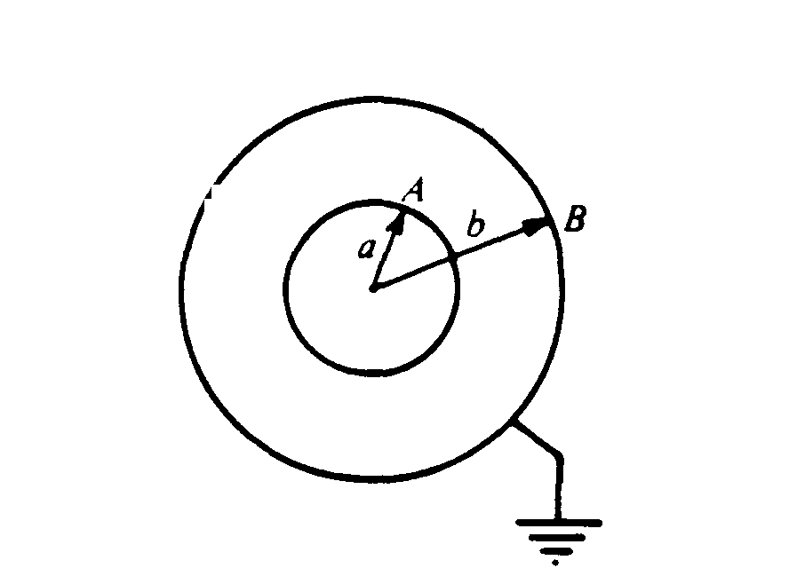  conc shells, Gauss’ Law, potential |  | 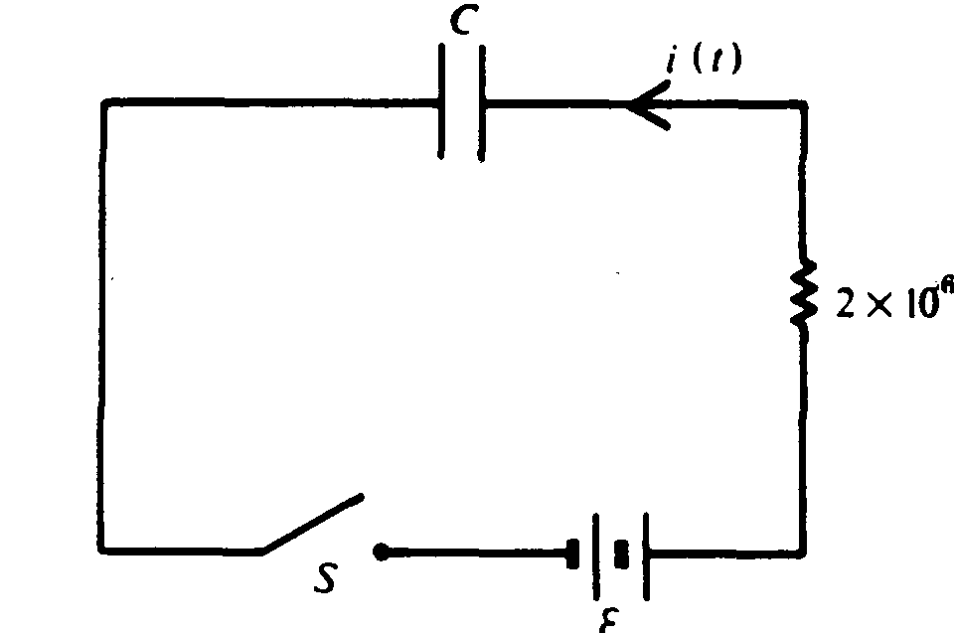  R-C circuit |  | 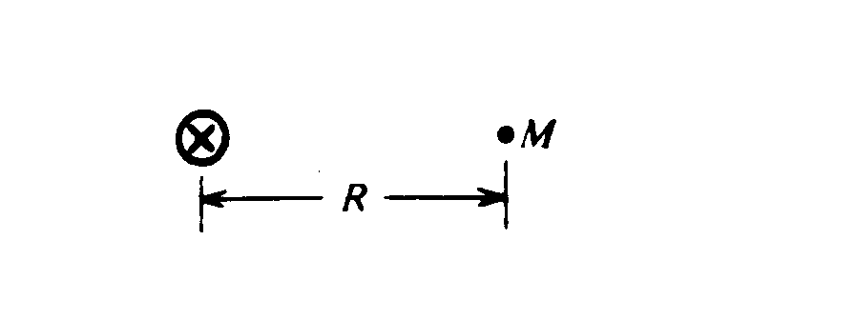  Superimposed B fields from wires.
1  9  8  4 | s  o  l  n | 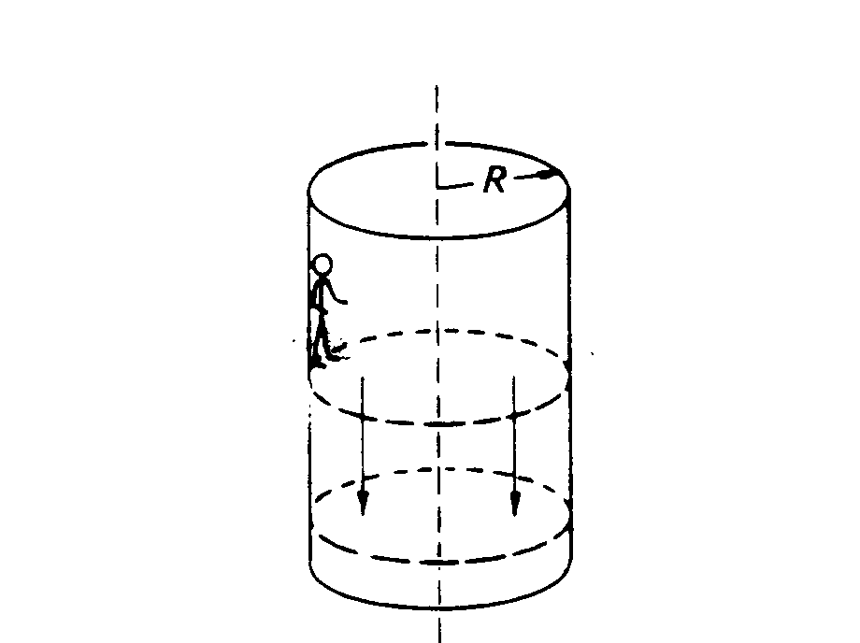  1984 - Centripetal motion, force diagram |  |  | 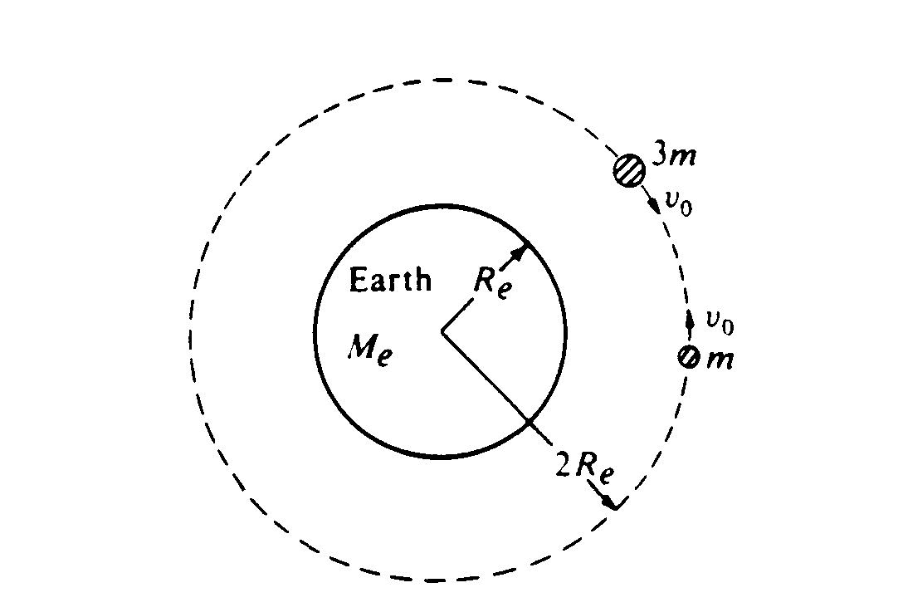  Orbits, mom cons, energy. |  | falling through a resisting medium |  |  |  | 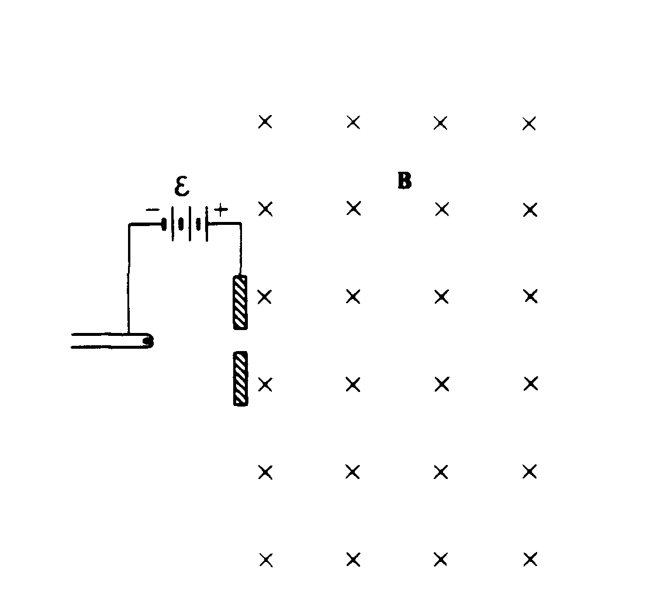  E and B forces on moving charge. |  | 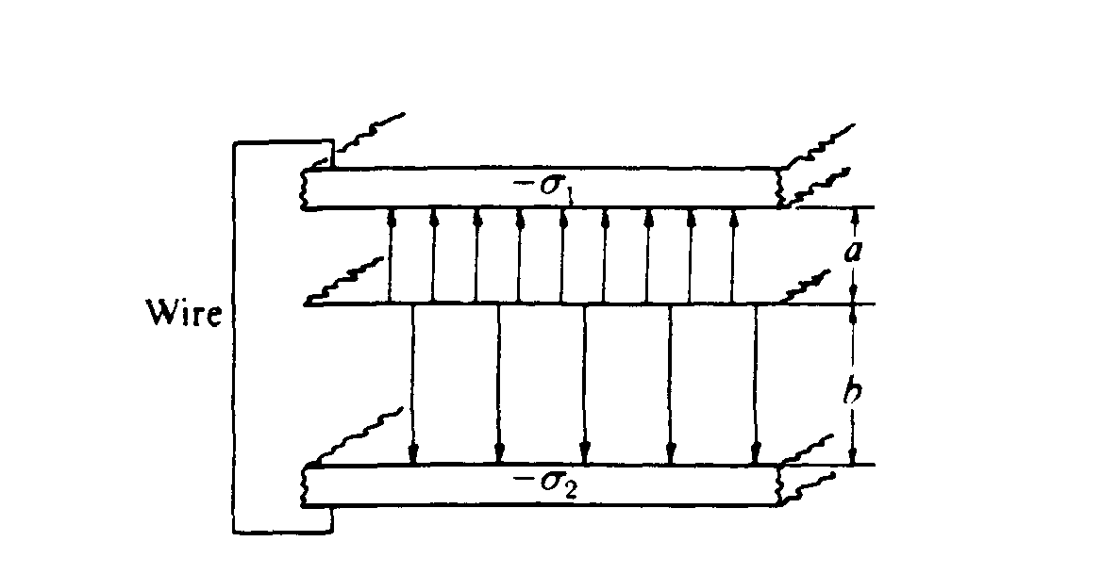  Gauss’ Law betw parallel plates. |  | 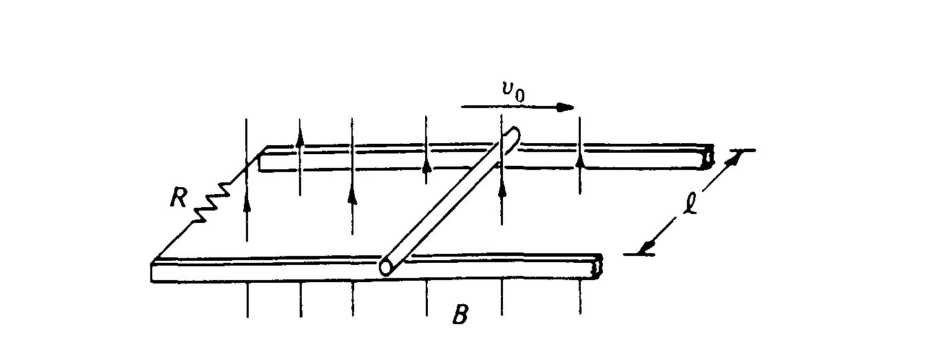  motional Emf bar decelerates. Power
1  9  8  5 | s  o  l  n | 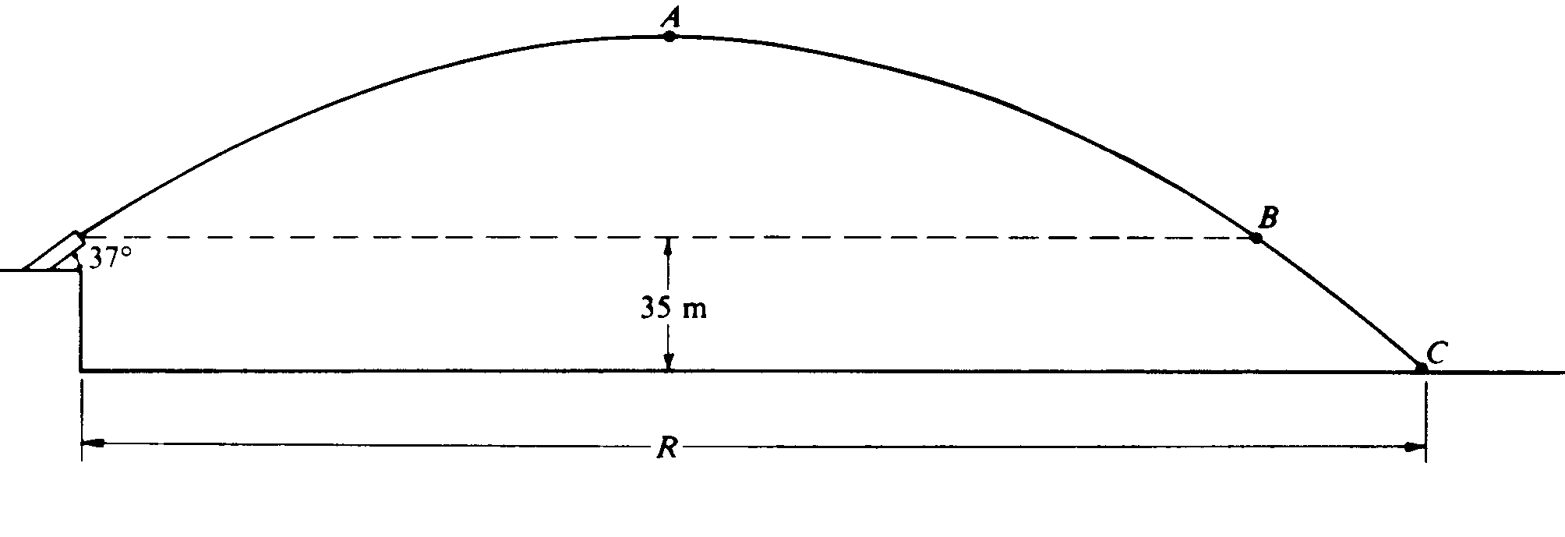  1985 – Projectile, cons of momentum |  |  | 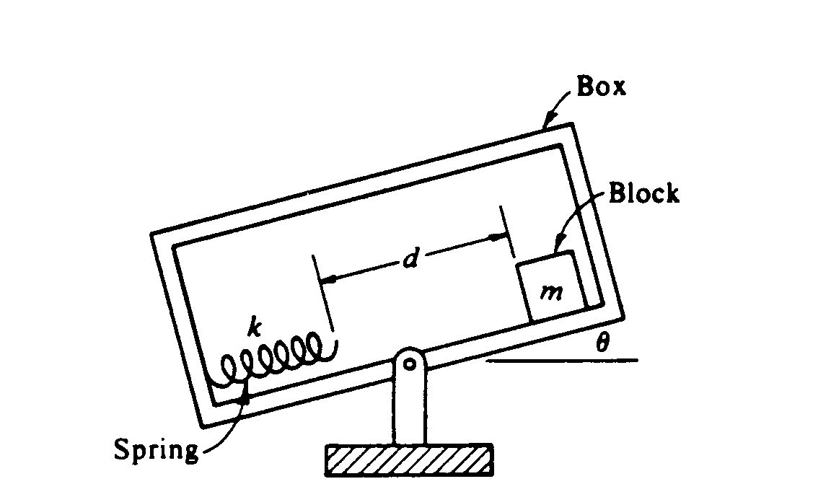  spring on an incline, energy cons |  | 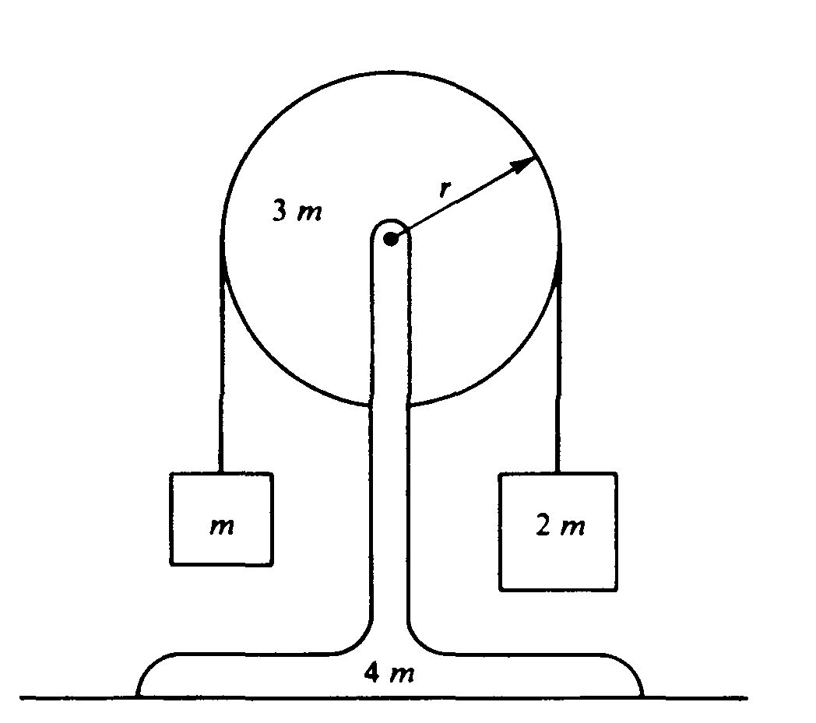  Atwoods mach, eqns of motion. |  |  |  | 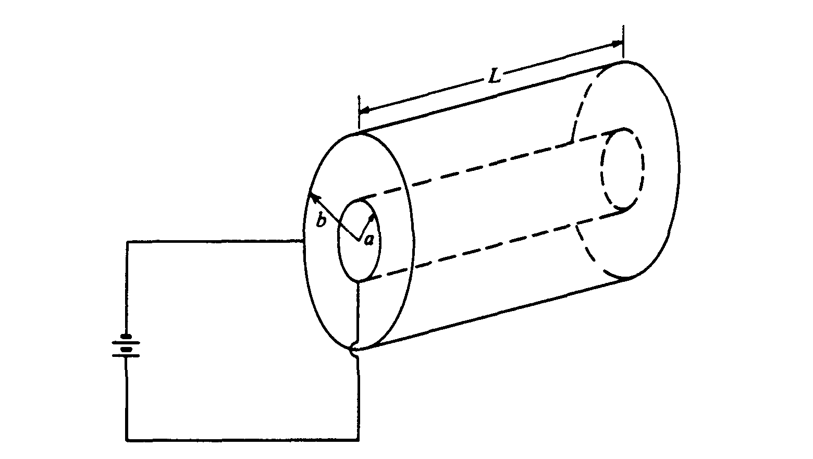  coax cylinders, Gauss’ law, cylindrical capacitor |  | 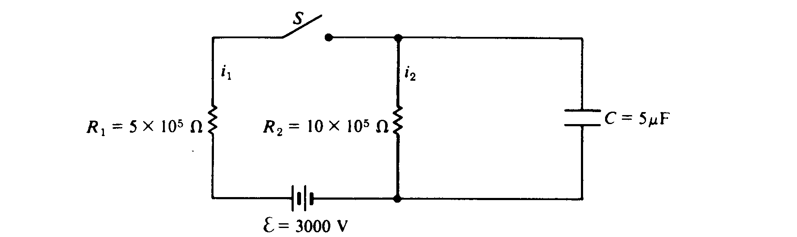  Circuits, R-C |  | 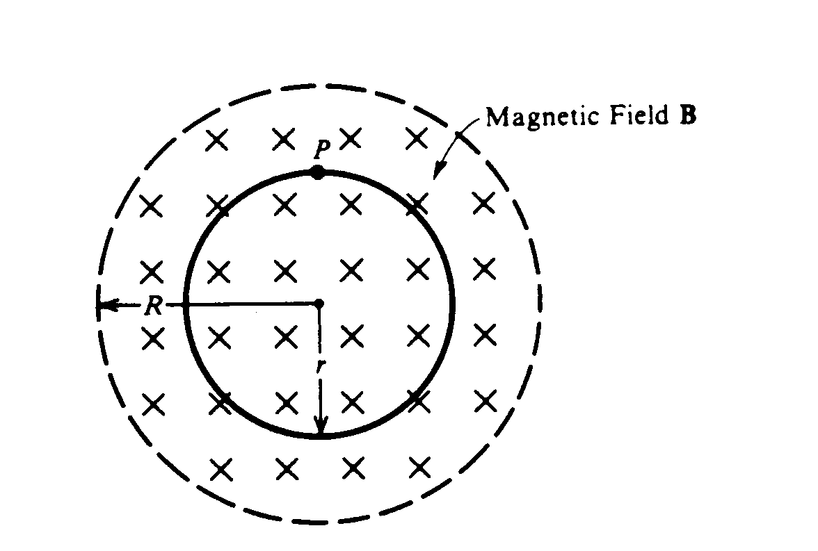  Faraday’s law, induced Emf, E.
1  9  8  6 | s  o  l  n | 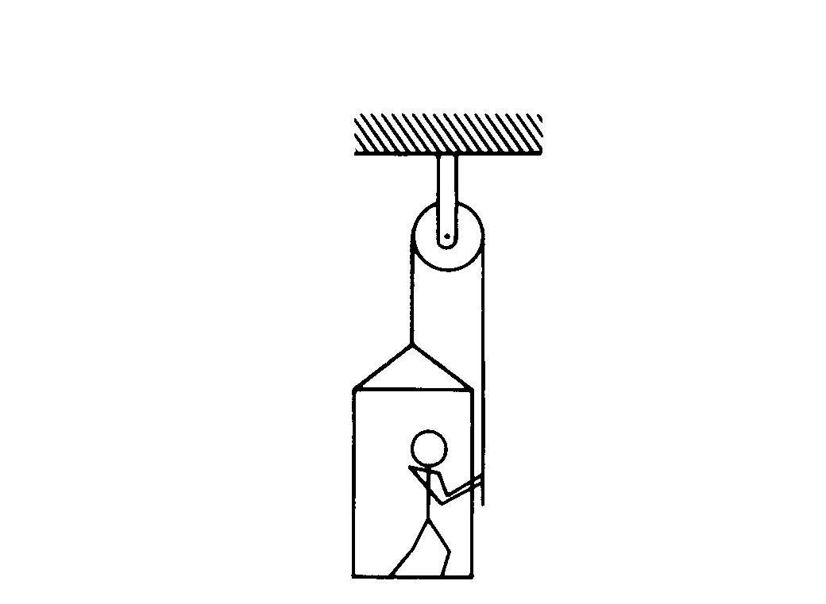  1986 – platform acc upward. Power |  |  | 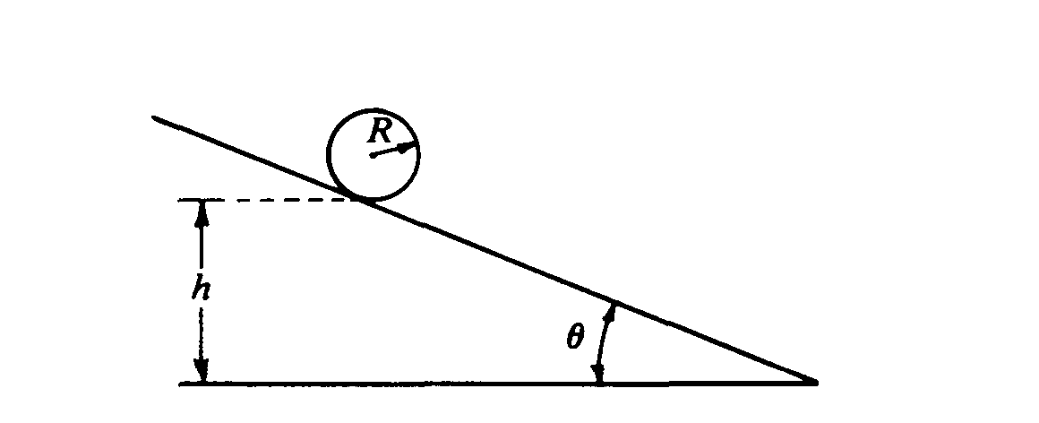  sphere on incline, I, acceleration. |  | - F = -kx³. Non linear spring, SHM |  |  |  | 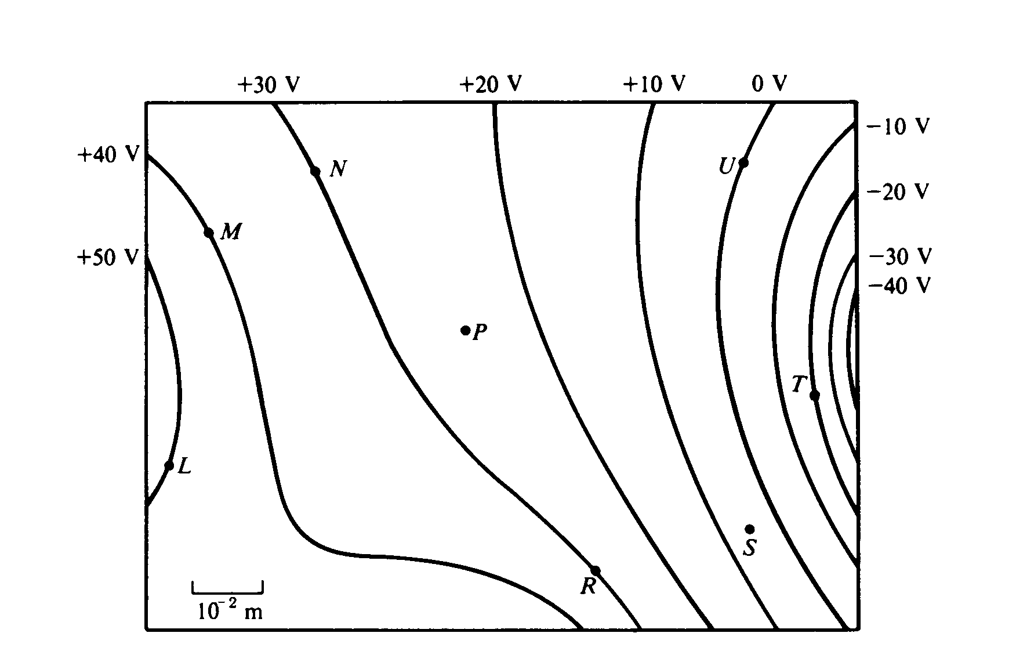  Equipotentials and fields, work |  | 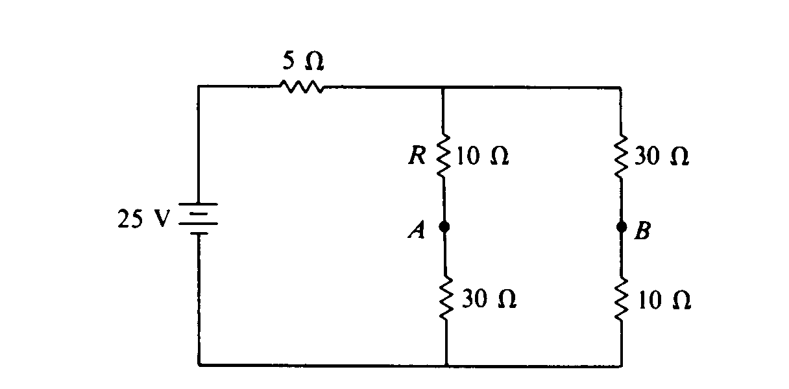  Circuit, add C, add L. |  | 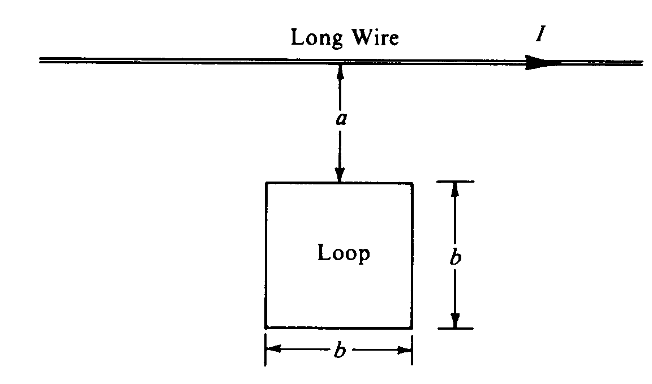  Long wire B, flux thru nearby loop, induced I
1  9  8  7 | s  o  l  n | 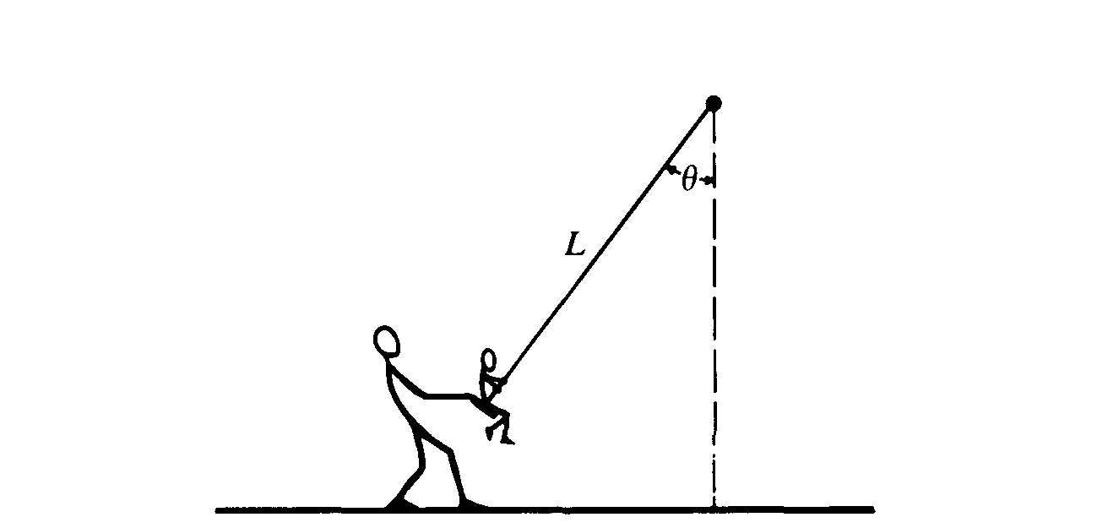  1987 – Centrip forces on a swing |  |  | 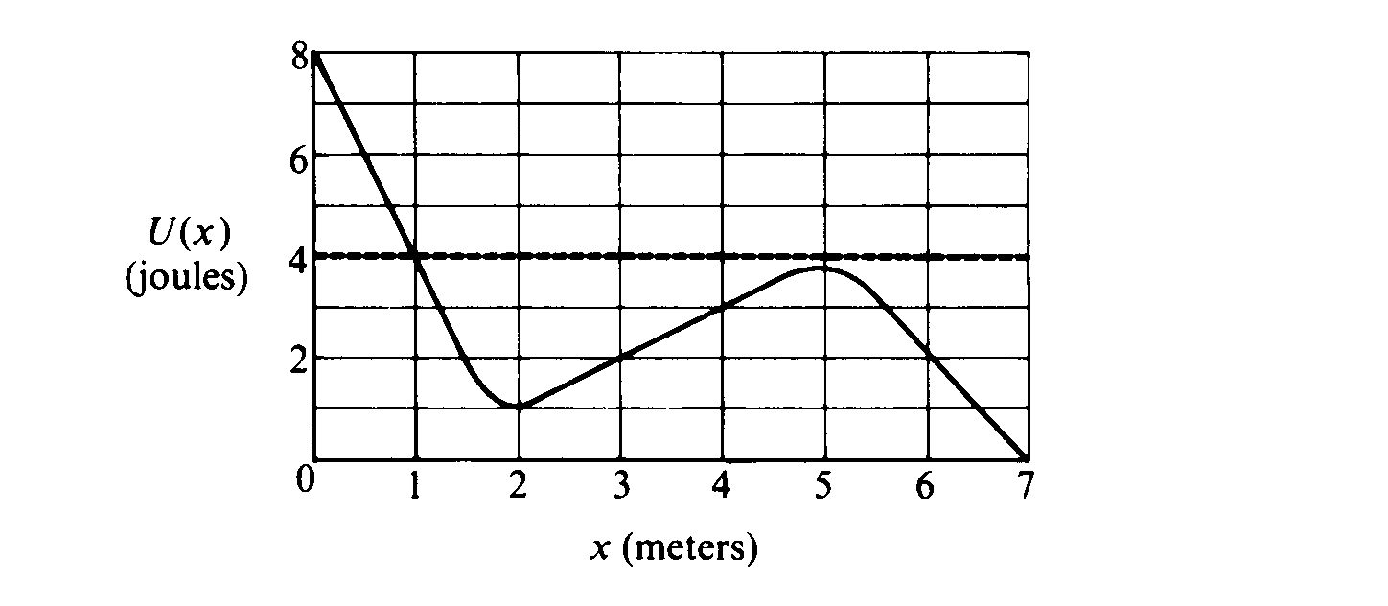  Potential Energy function. F = -dU/dr |  | 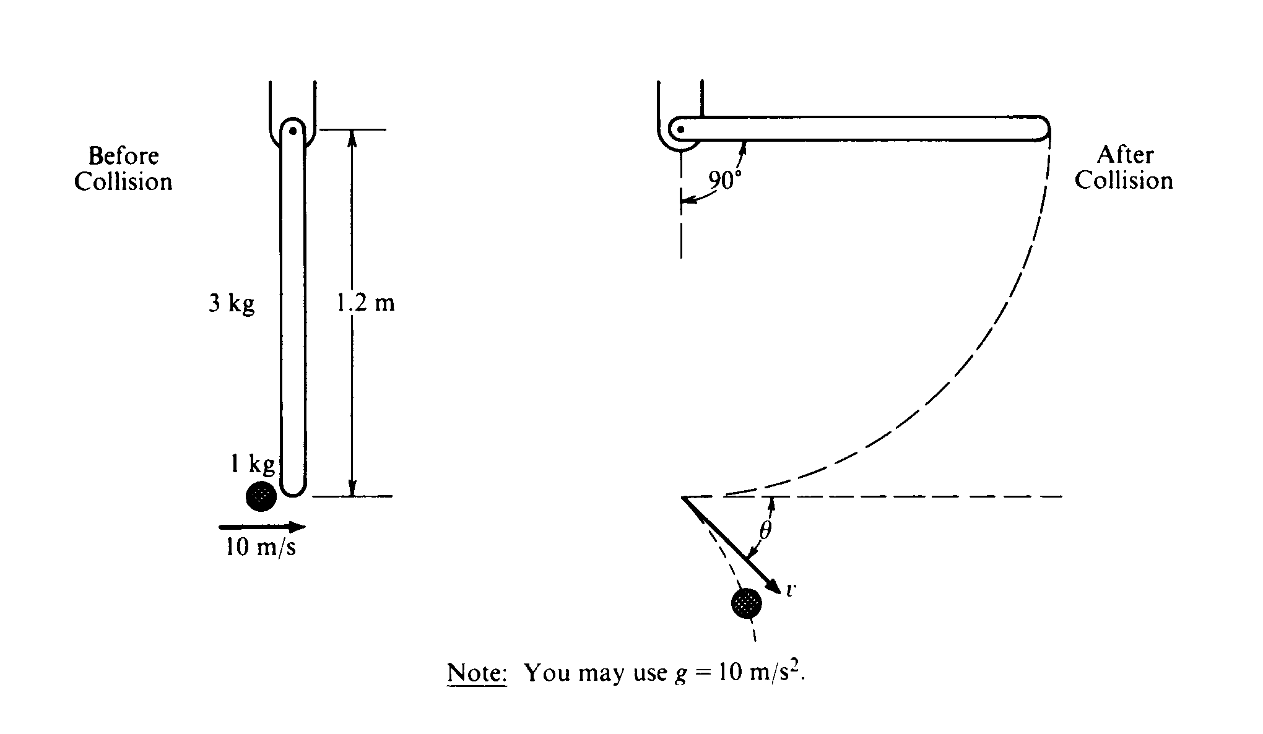  Cons of linear and ang momentum |  |  |  | Charge dist thru a sphere, Gauss’ law, potential |  | 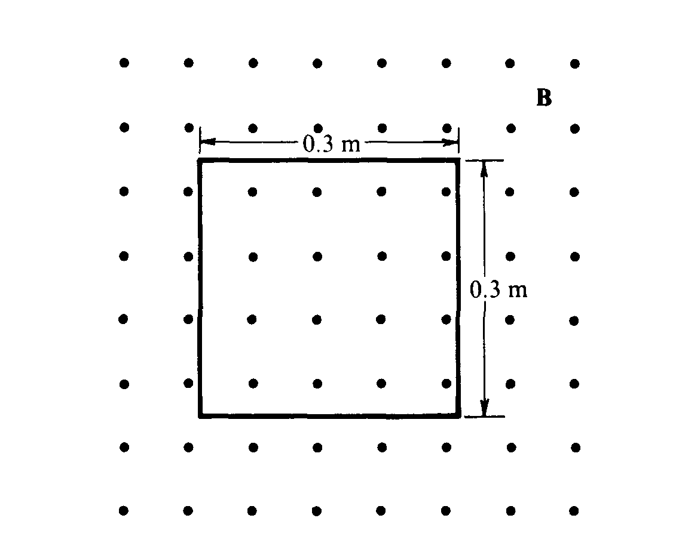  Flux, Faraday’s law, induced I, energy dissipated |  | 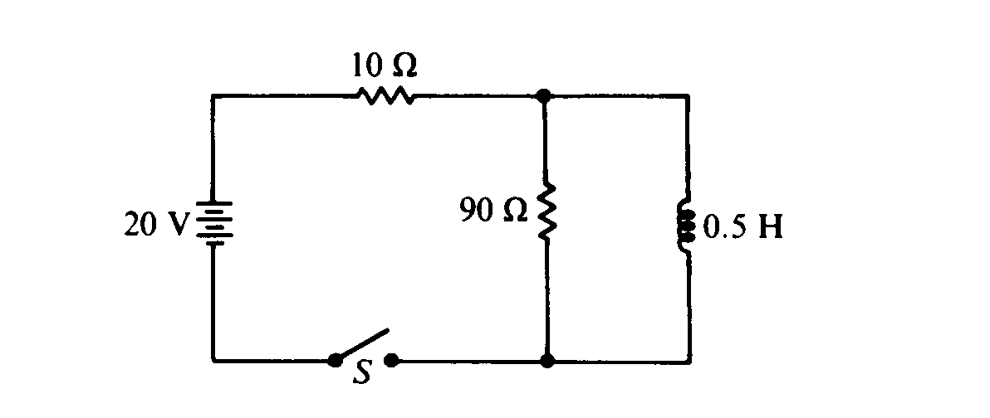  R-L Circuit.
1  9  8  8 | s  o  l  n | 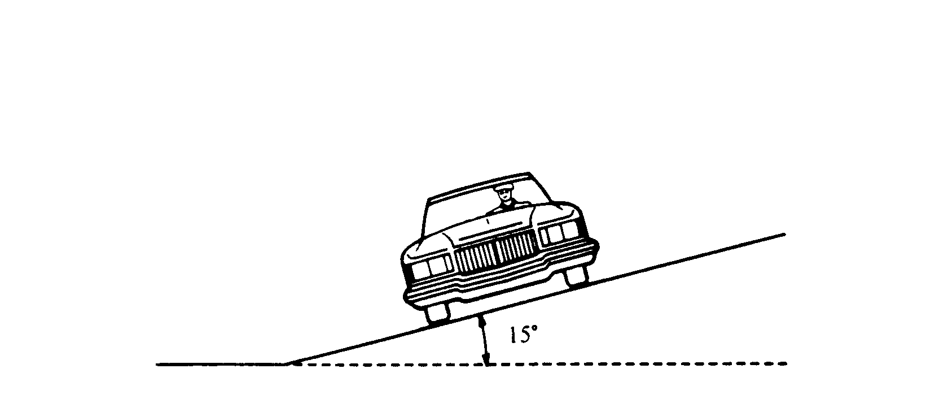  1988 – car on banked road |  |  | 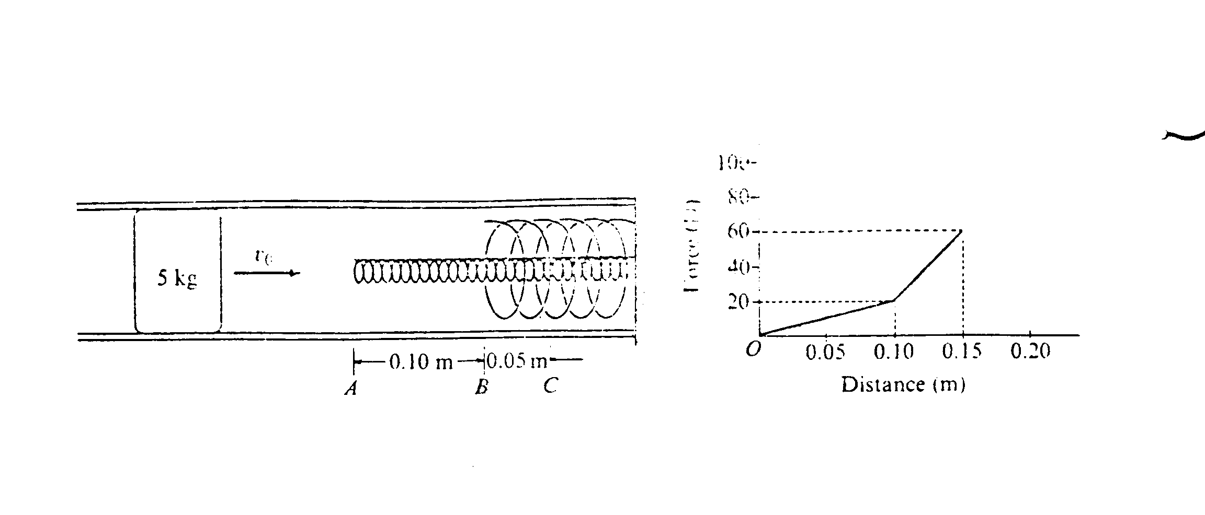  springs in parallel, work = area in F vs d |  | 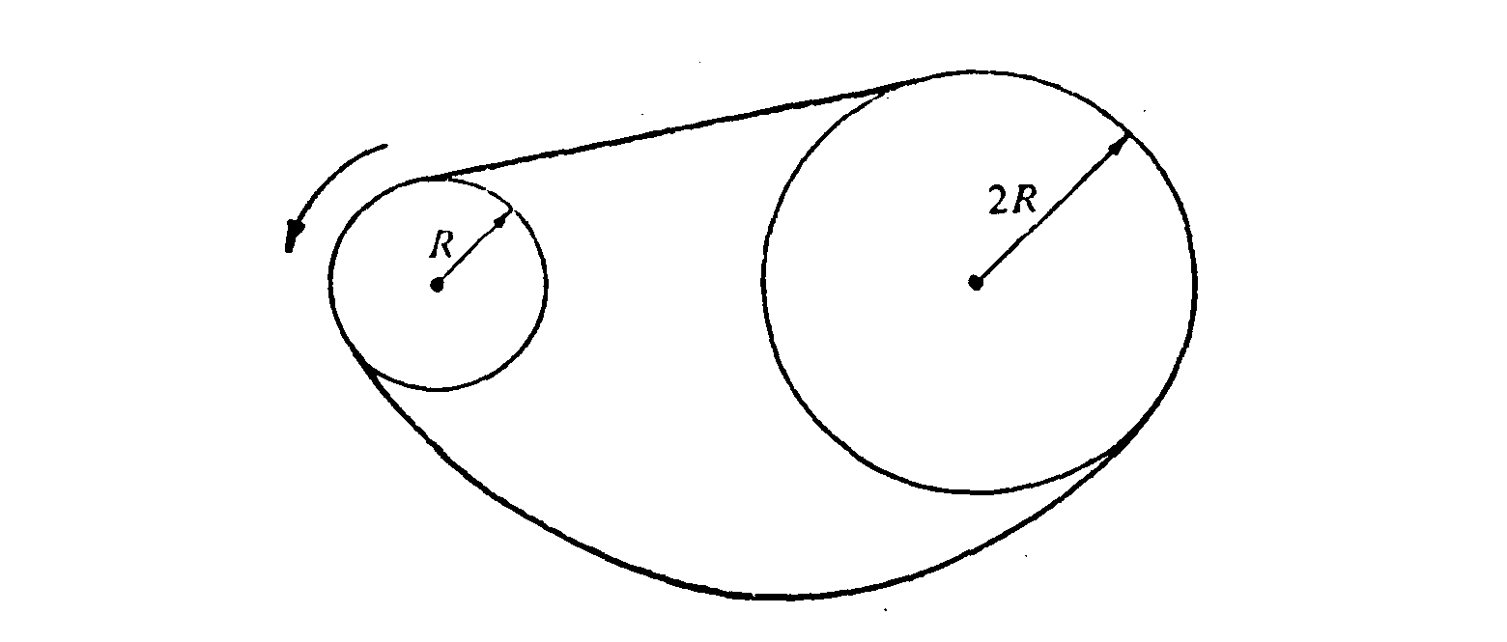  Angular motion, torque, acceleration |  |  |  | 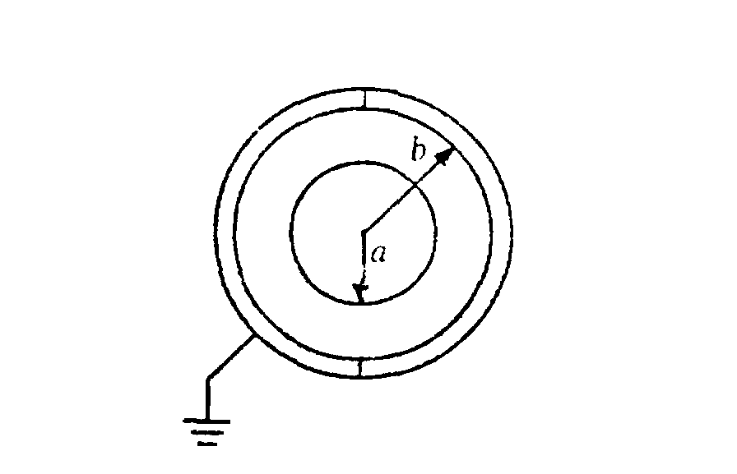  conc shells, Gauss’ law, potential, Capacit. |  | 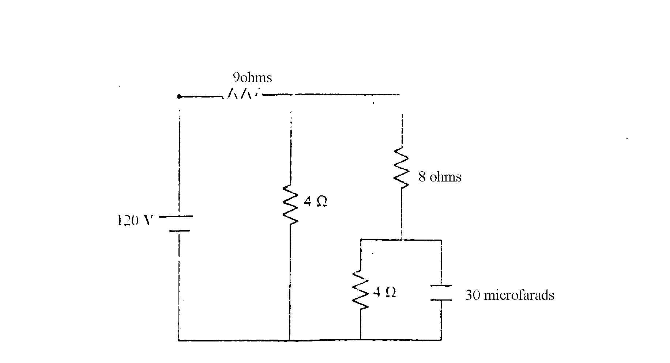  Circuit, with C. Energy dissipated. |  | 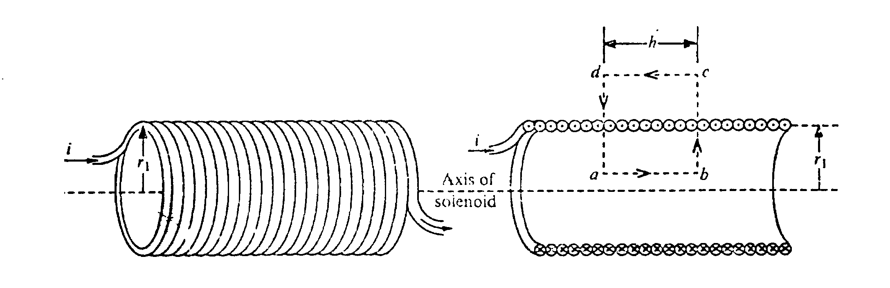  Solenoid, Amp law, flus induced Emf.
1  9  8  9 | s  o  l  n |  | 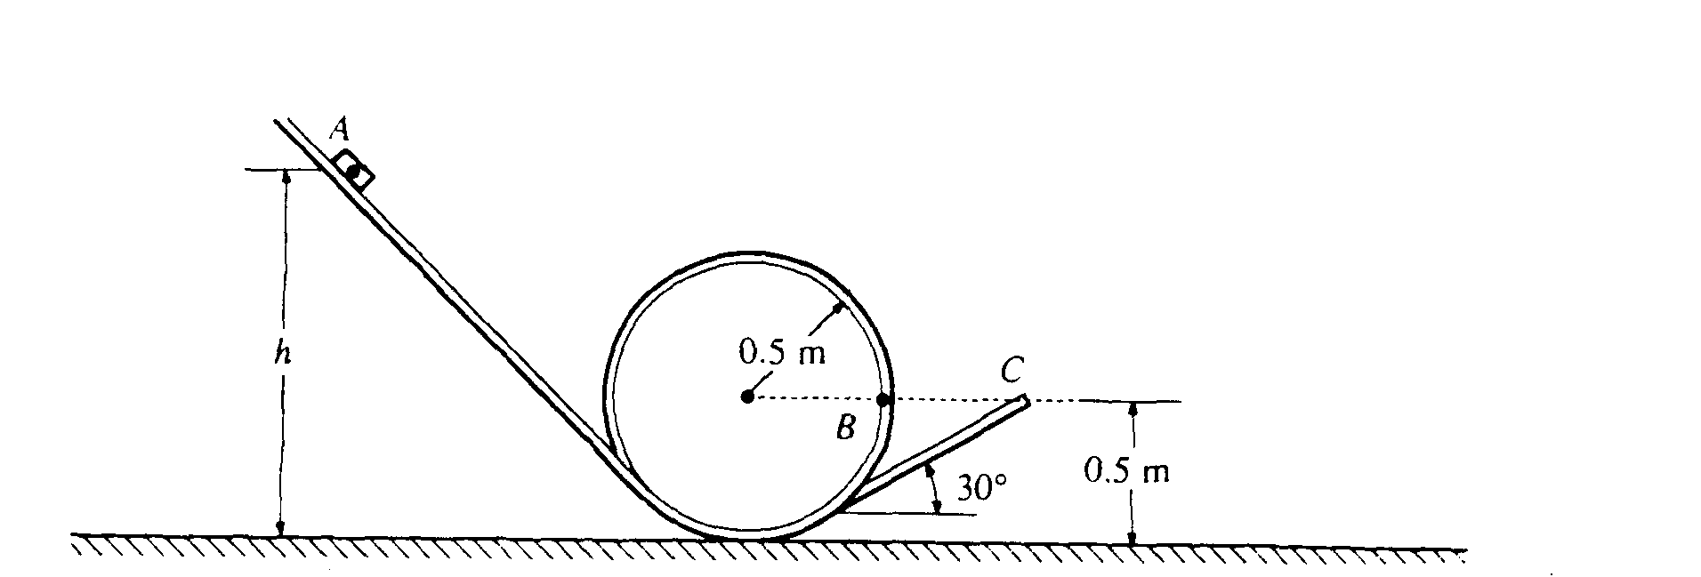  1989 - Energy cons, critical speed, vert circle |  |  | 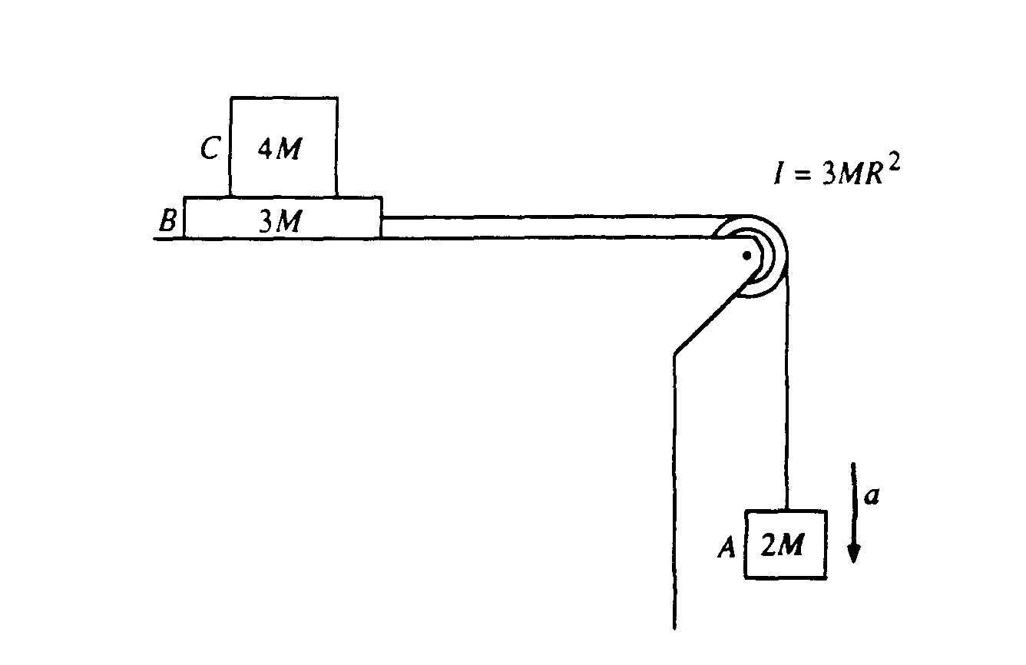  several bodies, heavy pulley, acc |  |  | 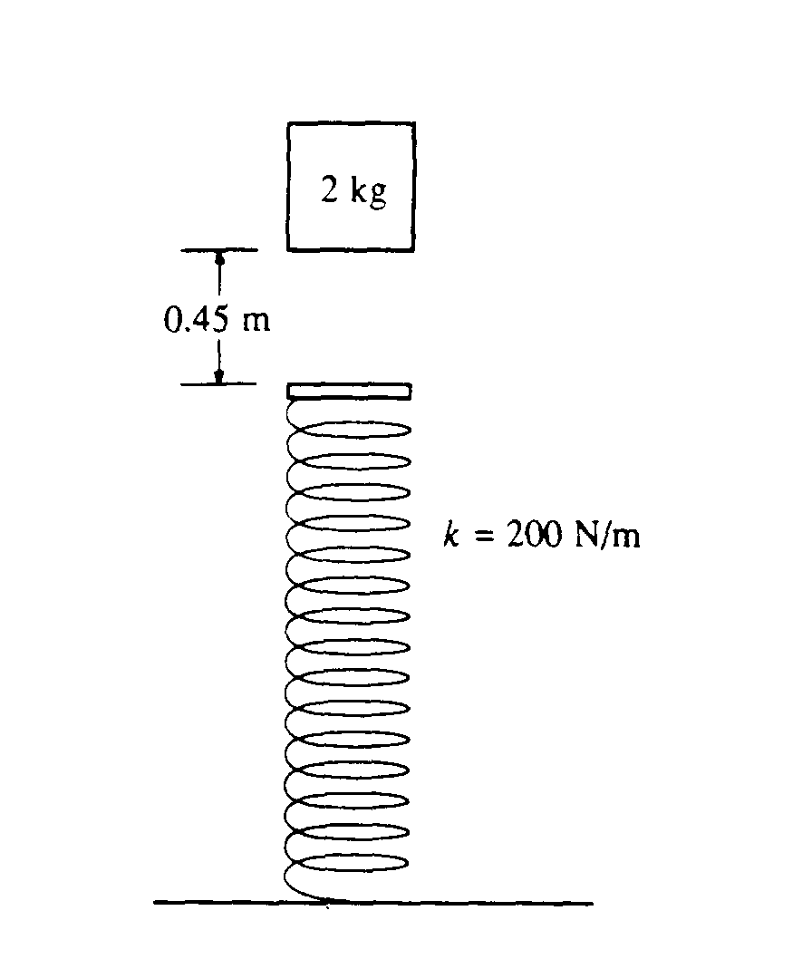  vert spring, SHM. |  |  | 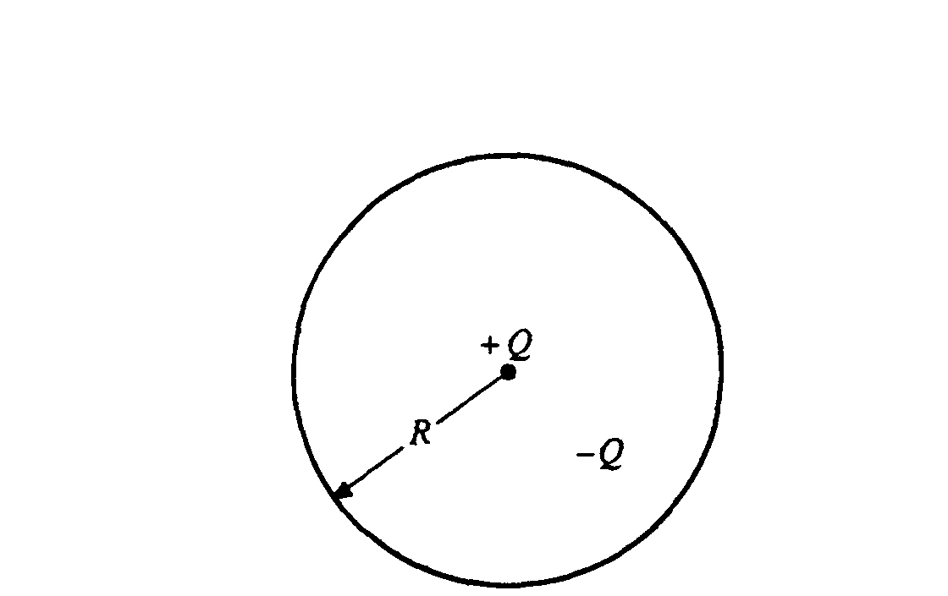  Two charges, E and potential |  | 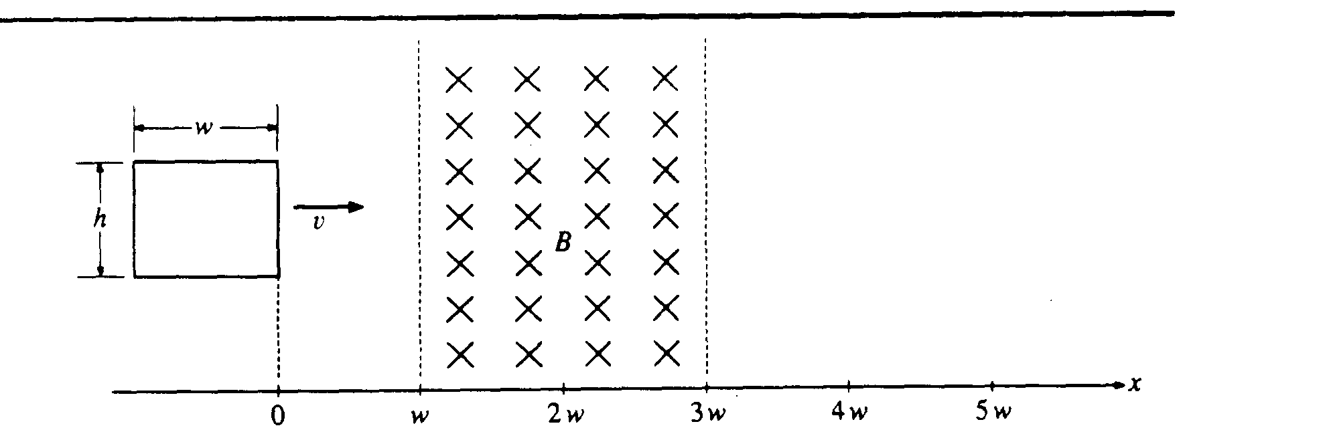  Motional Emf, induced current |  | 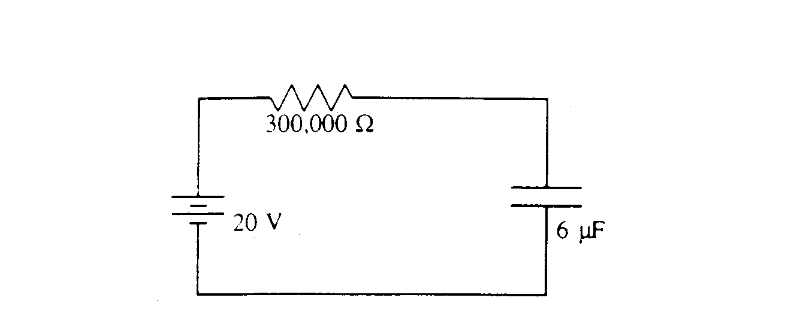  R-C circuit.
1  9  9  0 | s  o  l  n |  | 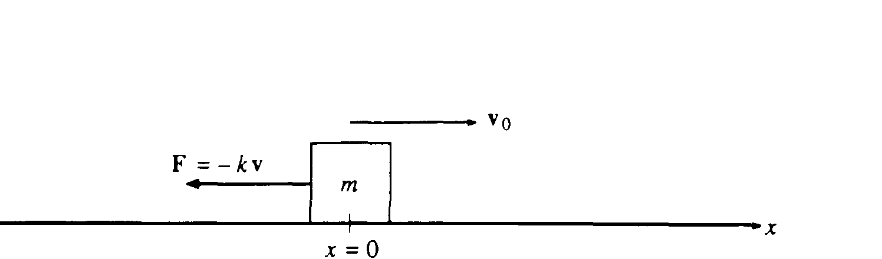  1990 - F = -kv, eqns of motion. |  |  | 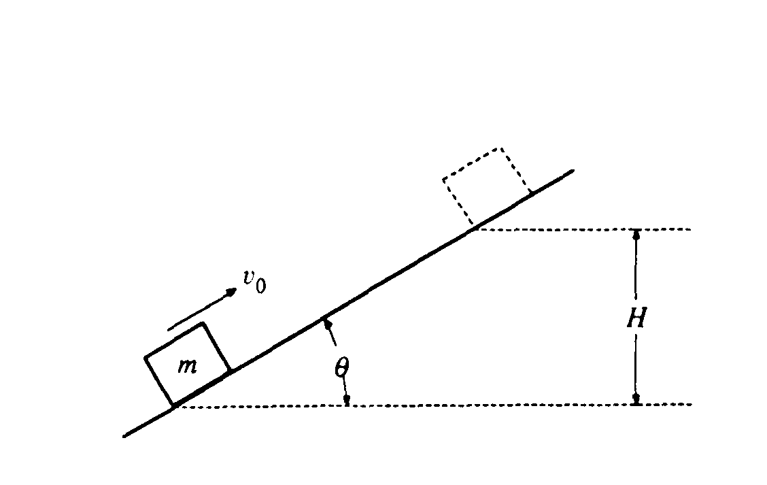  motion on incline, box and sphere. energy. |  |  | 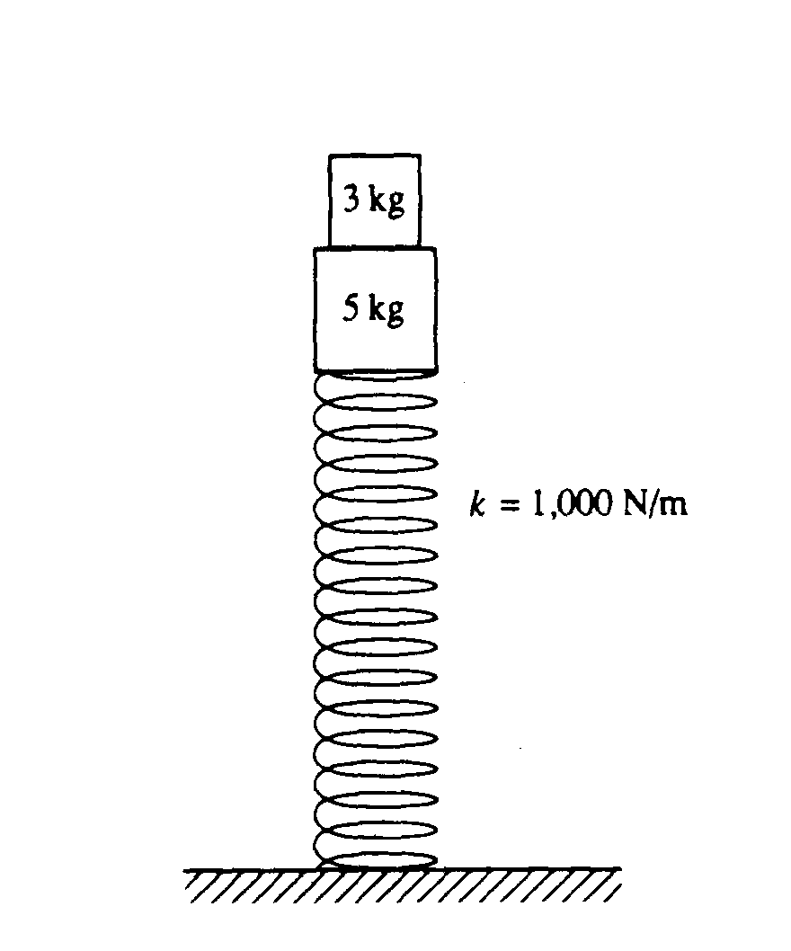  vertical spring, oscillation, energy |  |  | 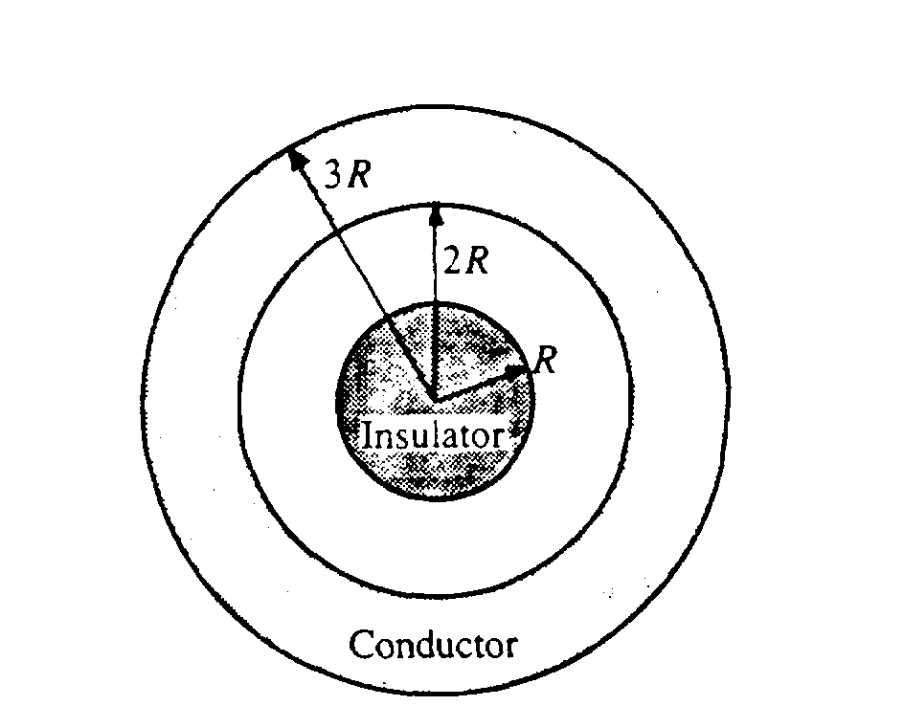  conc spheres, Gauss’ Law, fields |  | 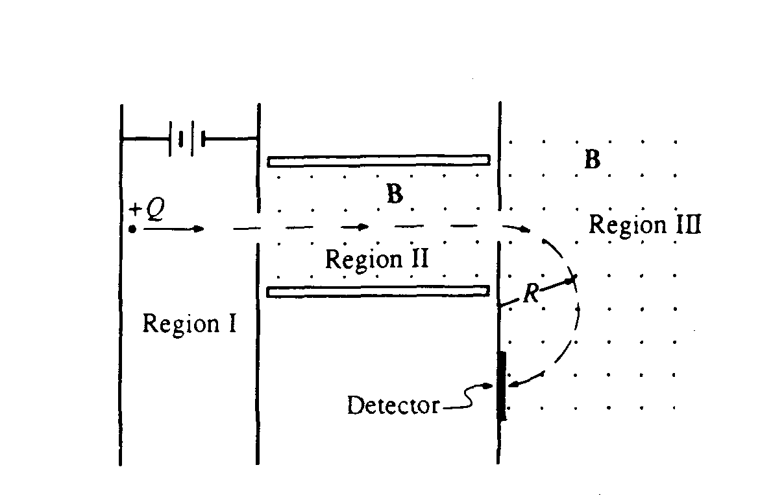  Mass spectrometer |  | 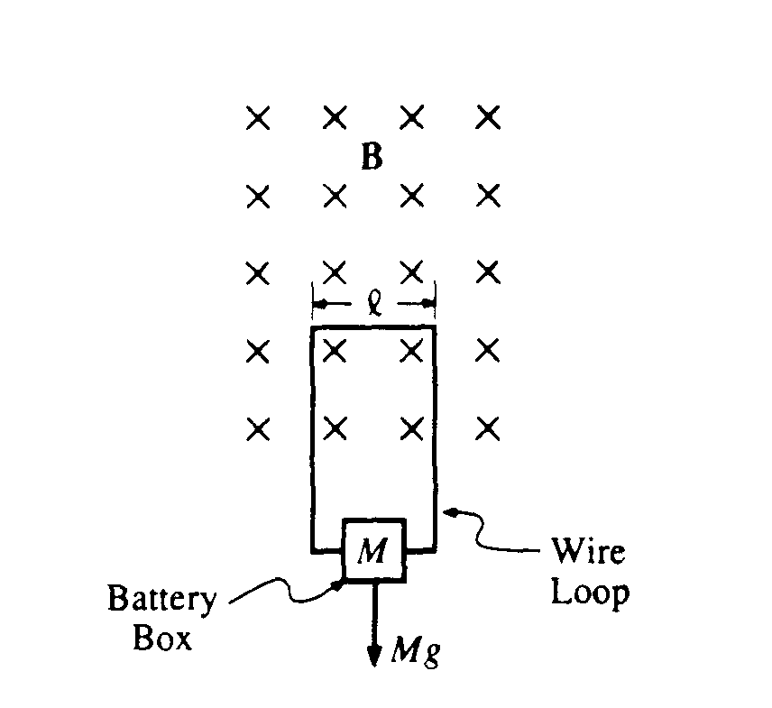  Falling through B field, induction, term velocity.
1  9  9  1 | s  o  l  n |  | 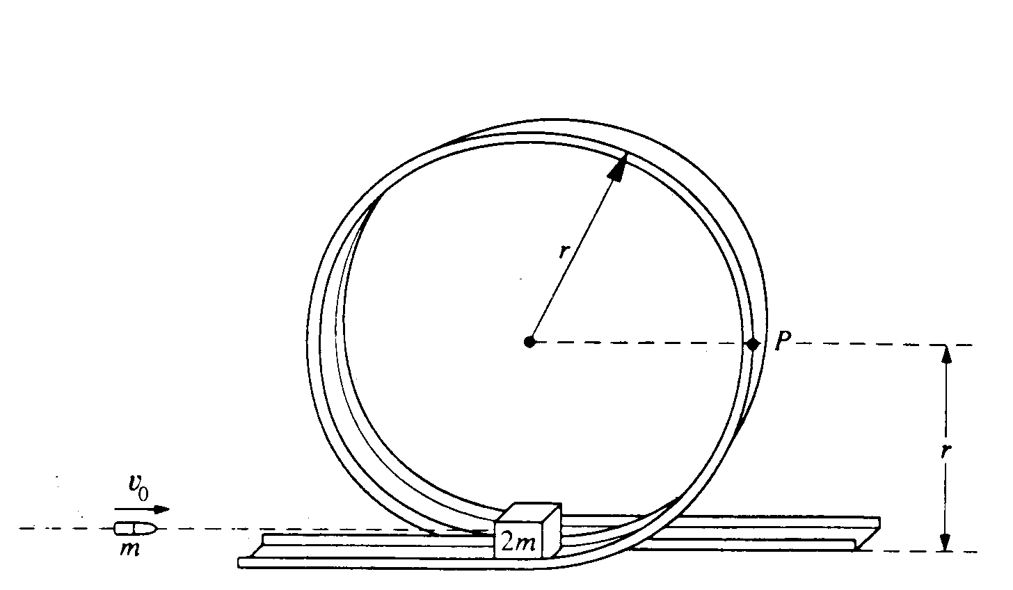  1991 - Ballistic Pend - cons of En and Mom - Vertical Circle |  |  | 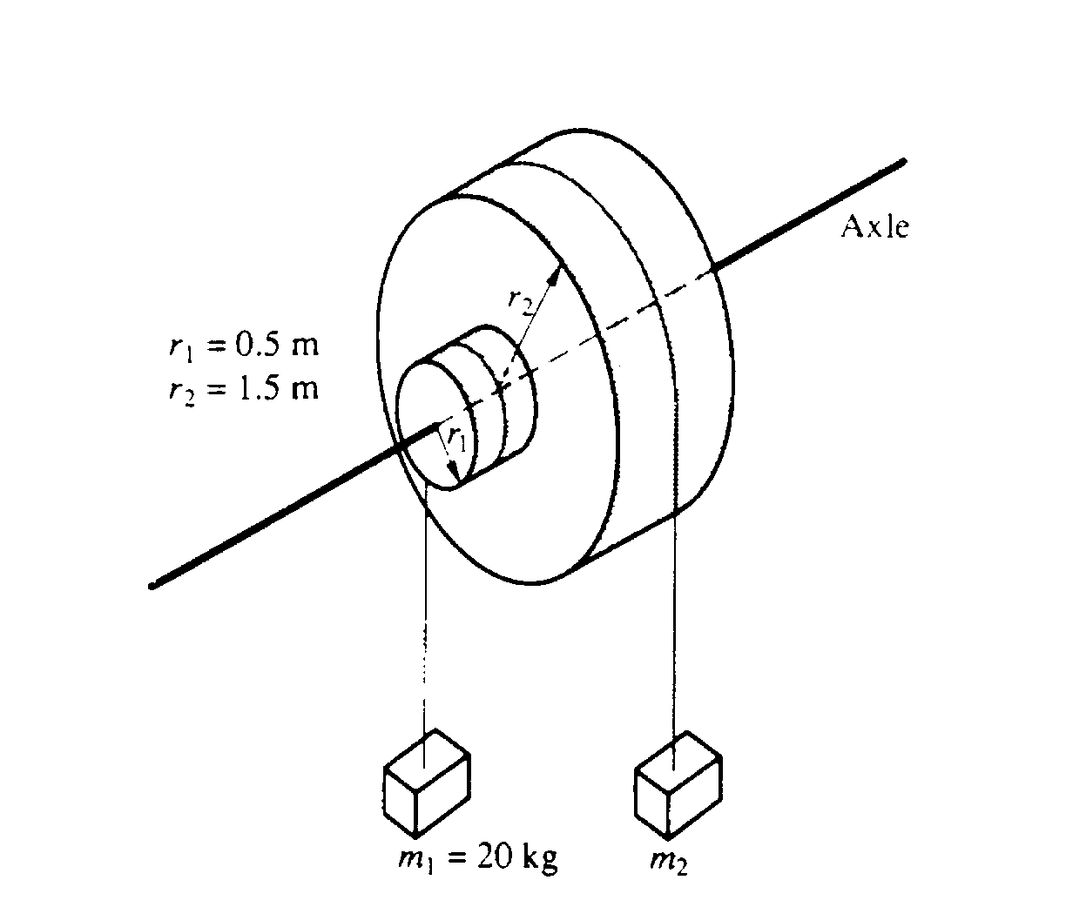  Rotation, torque |  |  | 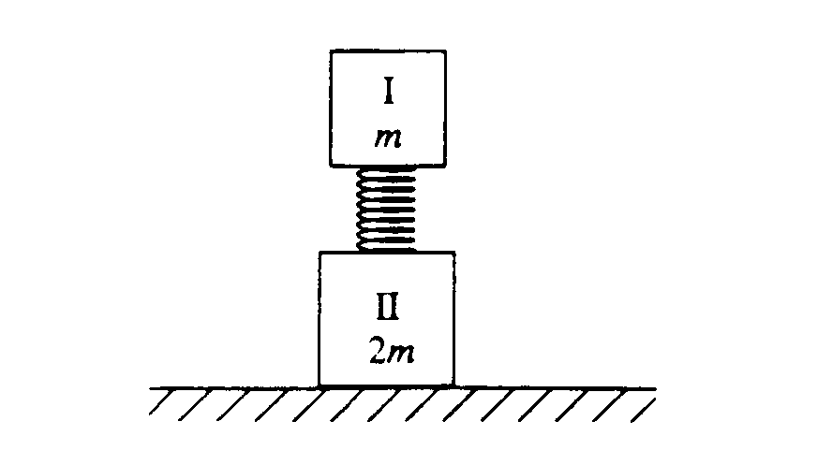  Spring, cons of mom and en, elastic collision |  |  | 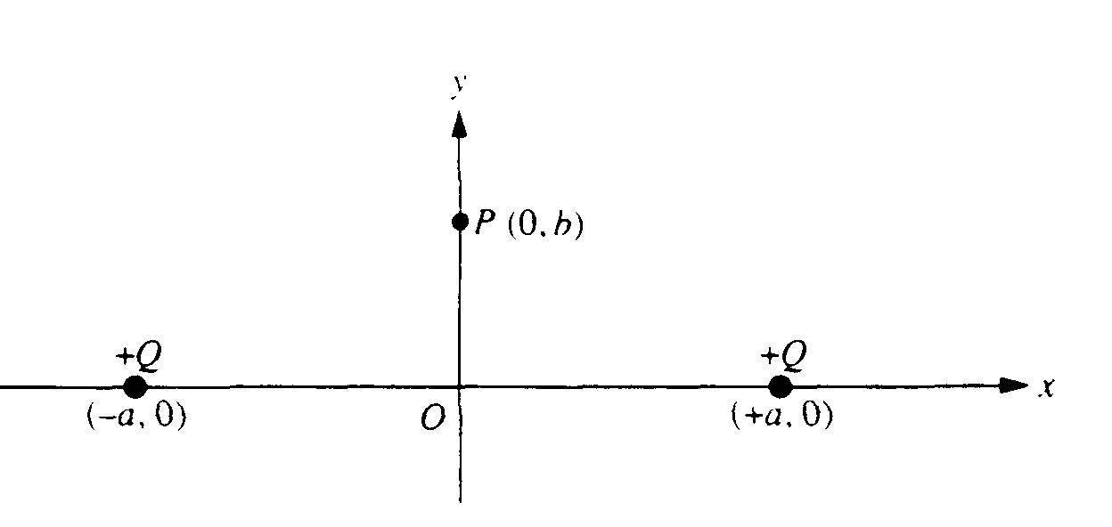  field and potential of point charges |  | 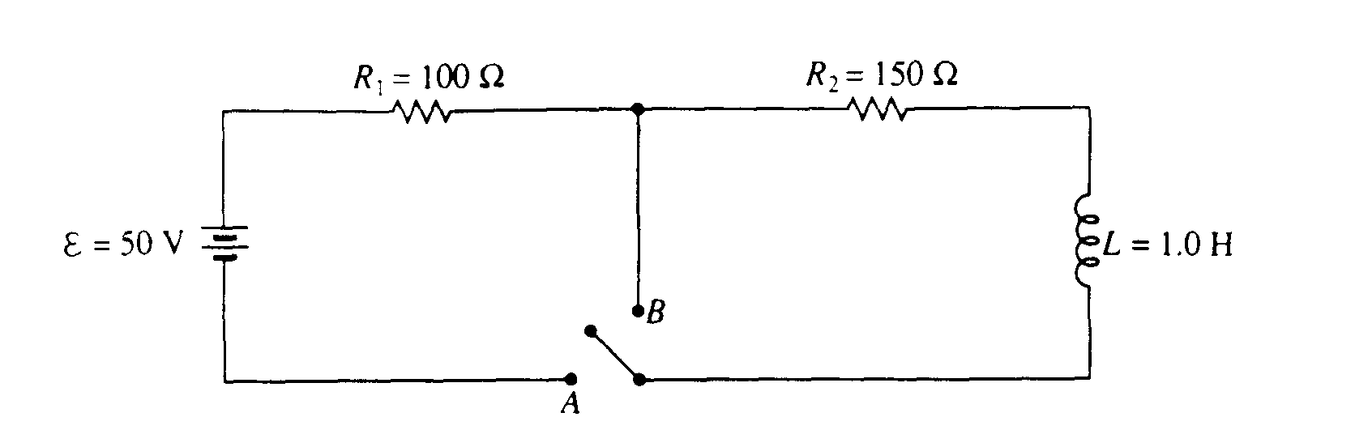  R - L circuit |  | 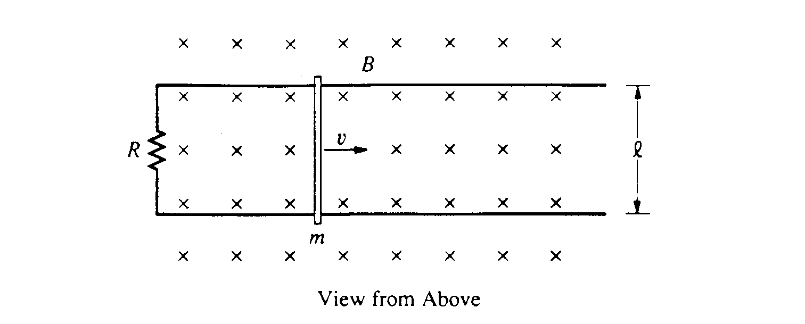  Faraday’s law, resisting medium
1  9  9  2 | s  o  l  n |  | 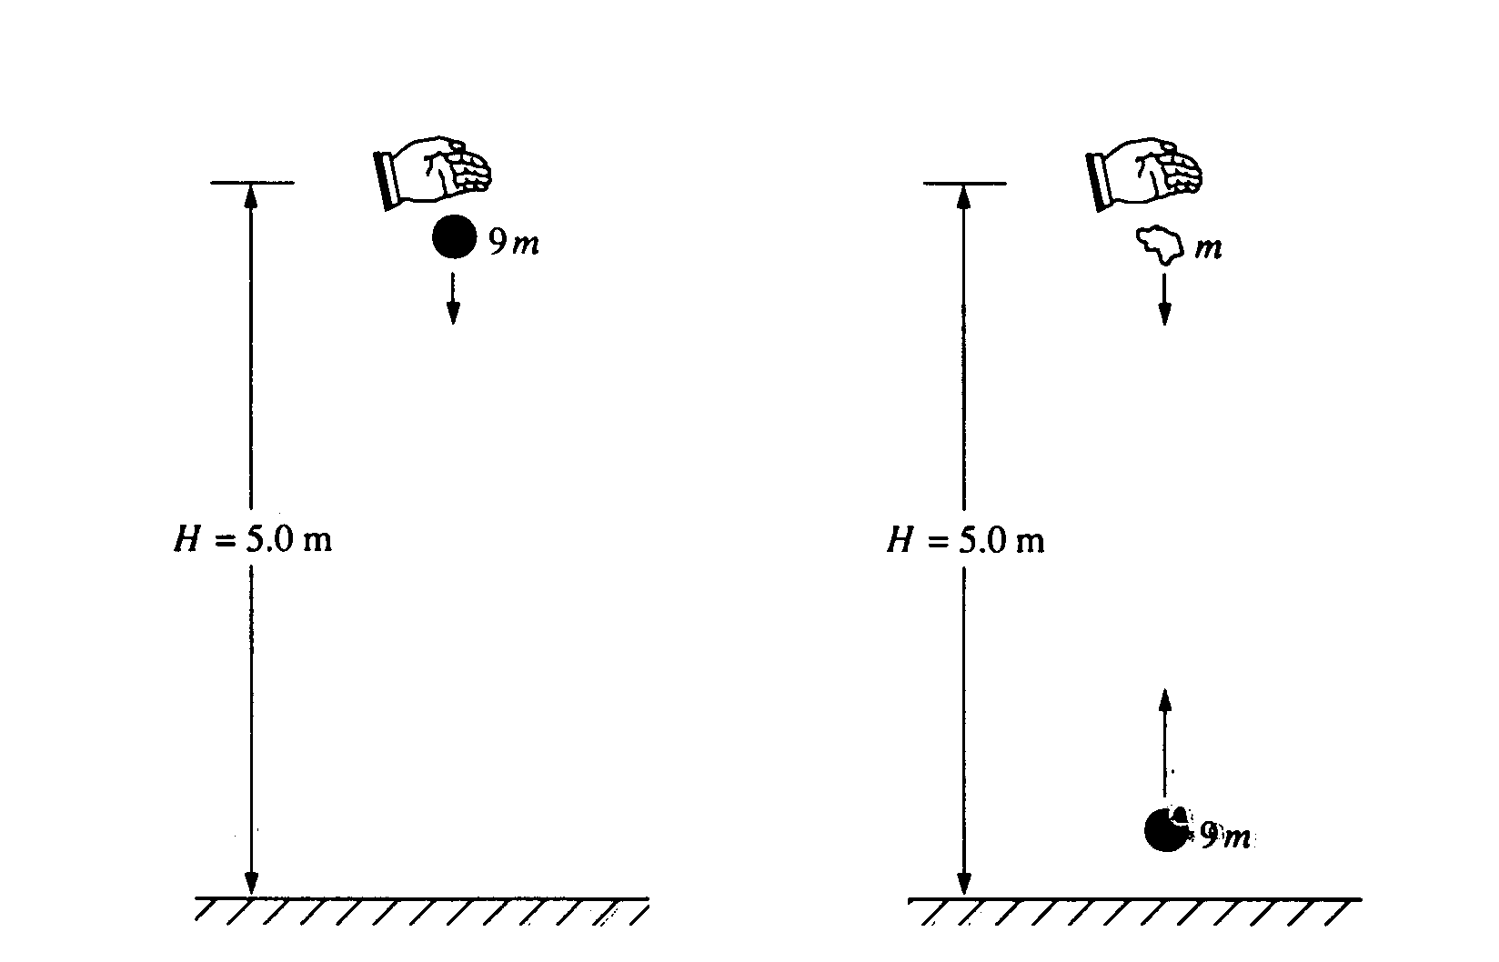  1992 - Energy, cons of mom, inelastic |  |  | 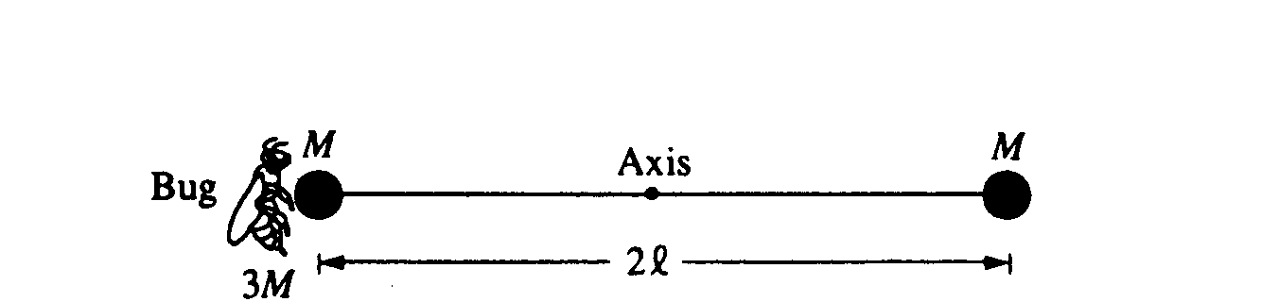  Rotation, I, torque, energy |  |  | 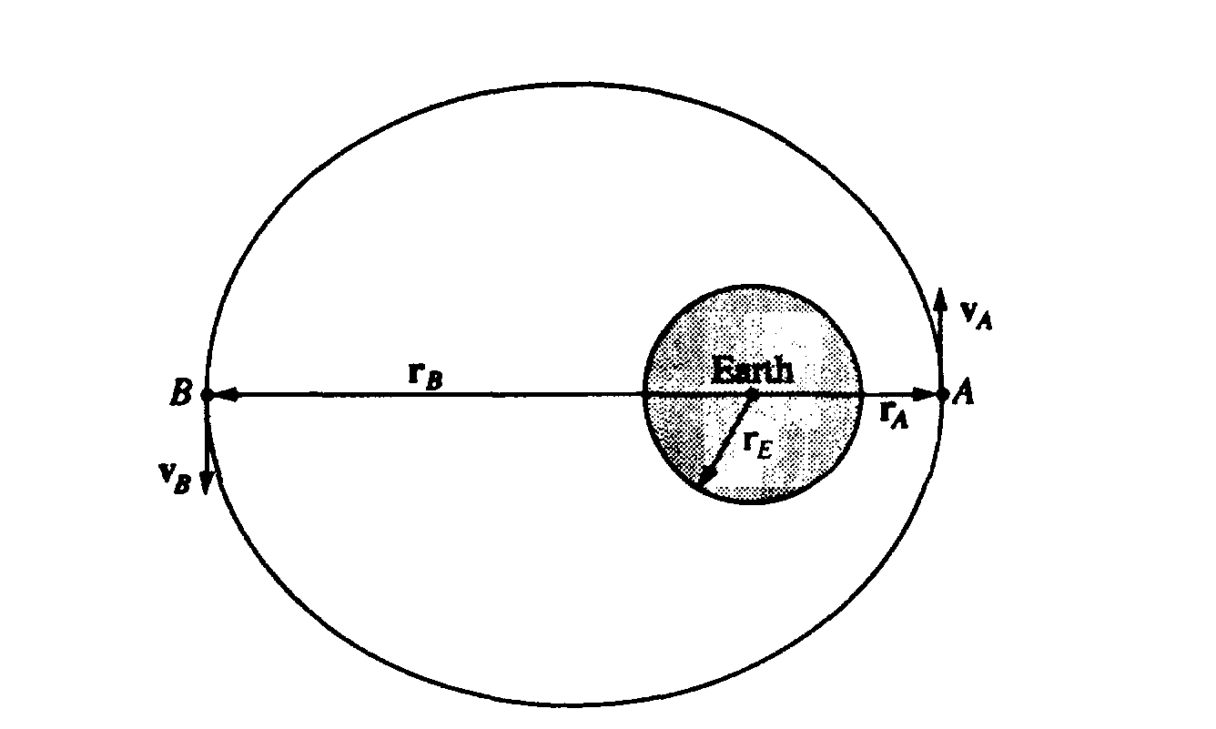  Orbits, cons of En and ang mom. |  |  | Charge dist in a sphere, find total charge, field with Gauss’ Law. |  | 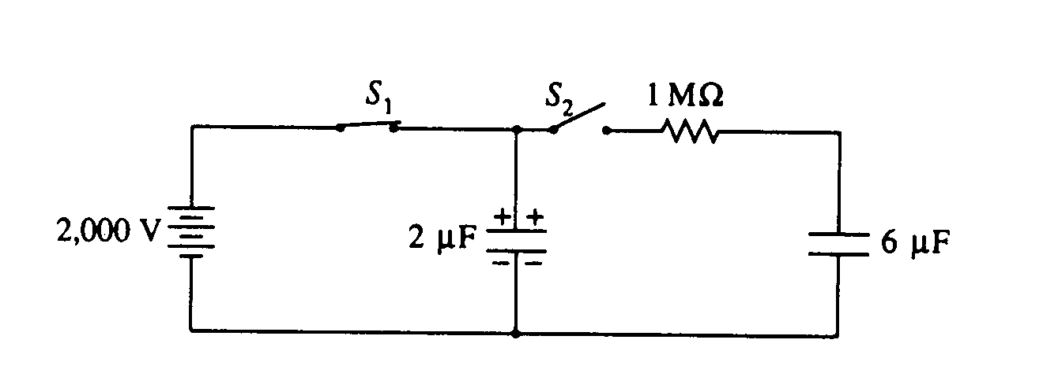  R - C circuit |  | 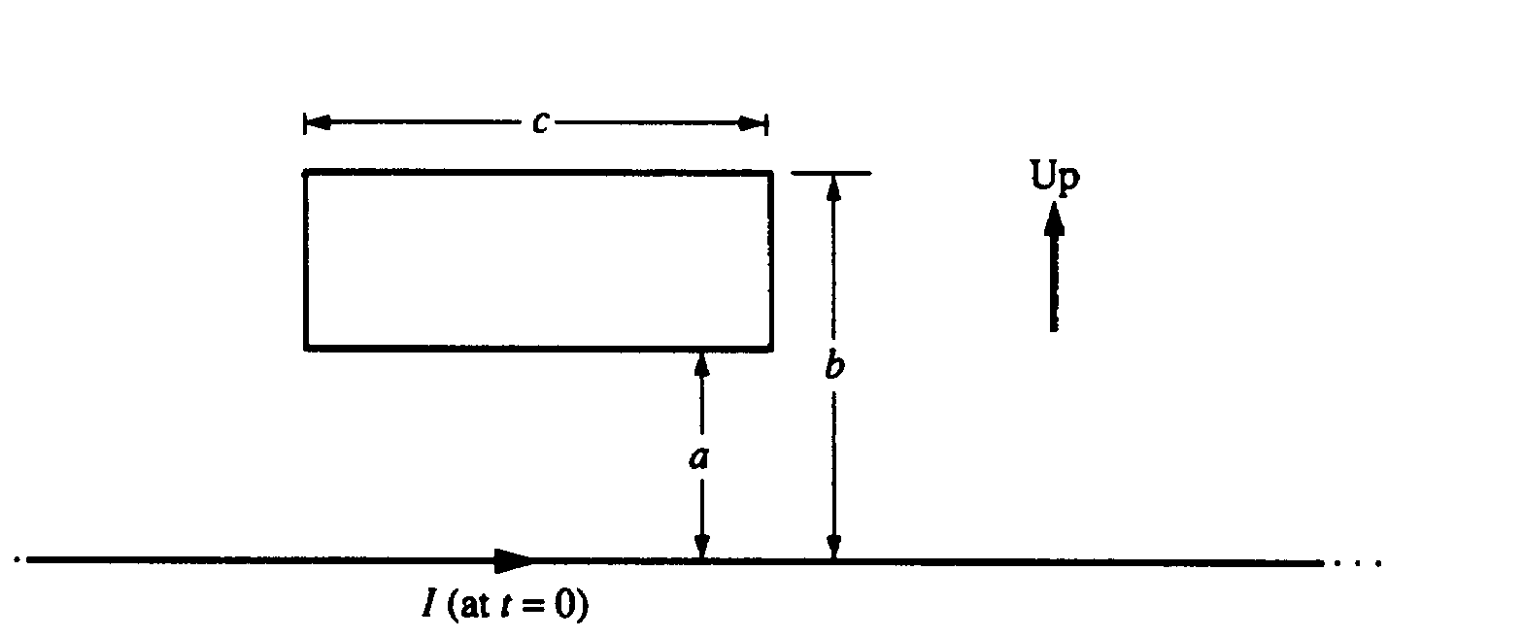  B field of wire, flux through loop, Faraday’s law
1  9  9  3 | s  o  l  n |  | 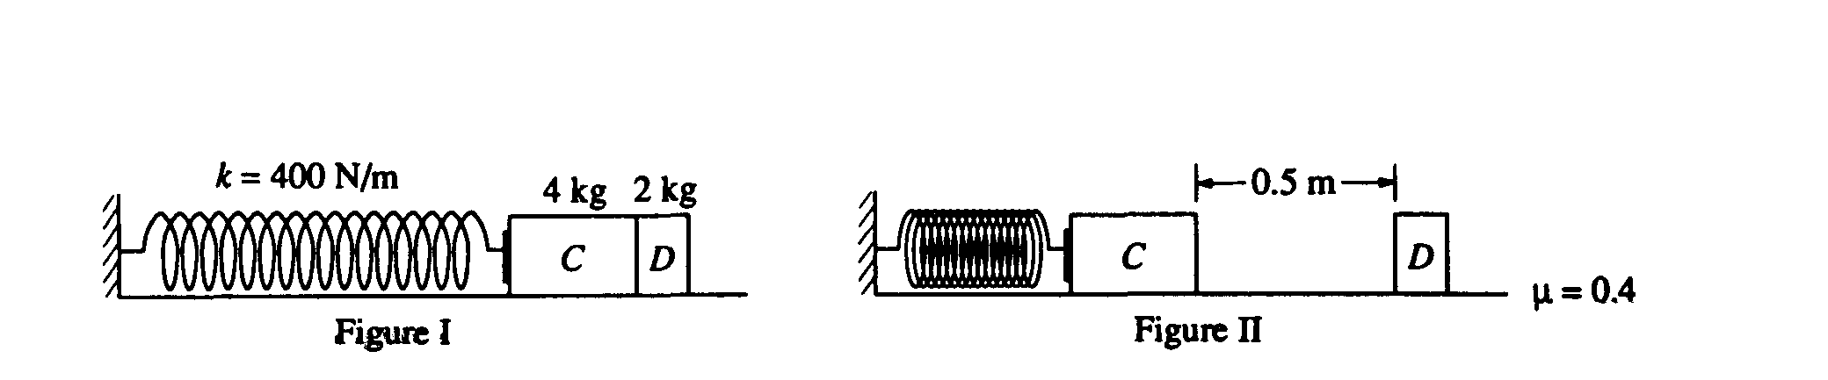  1993 - En in a spring, friction, cons of en. |  |  | 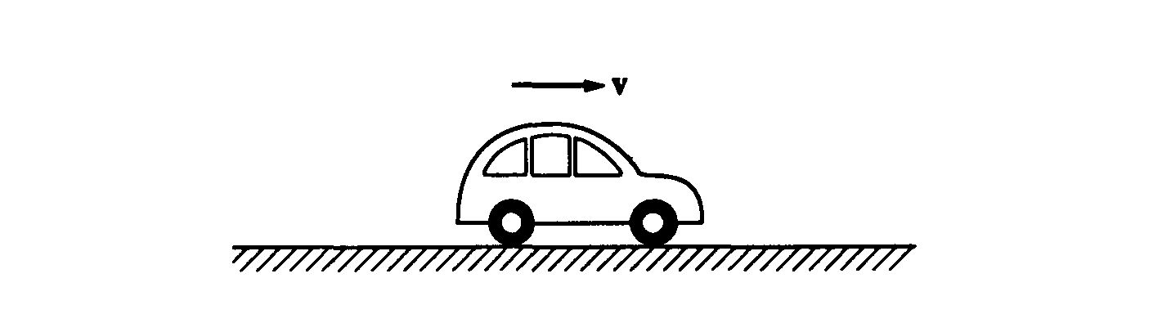  resisting medium, equations of motion. |  |  | 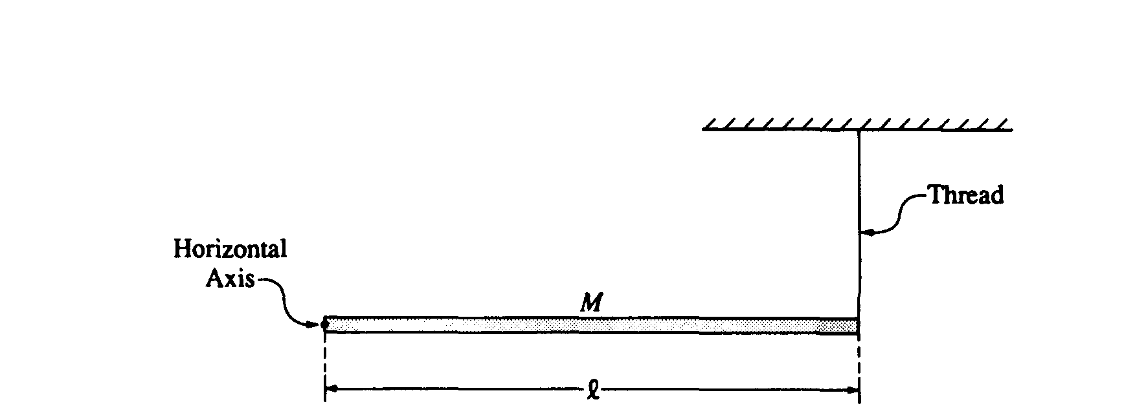  torque, angular acceleration. |  |  | 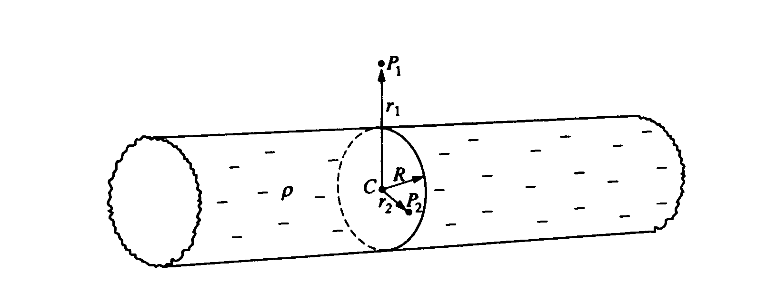  non conductor - Gauss’ law. conductor, Ampere’s law |  | 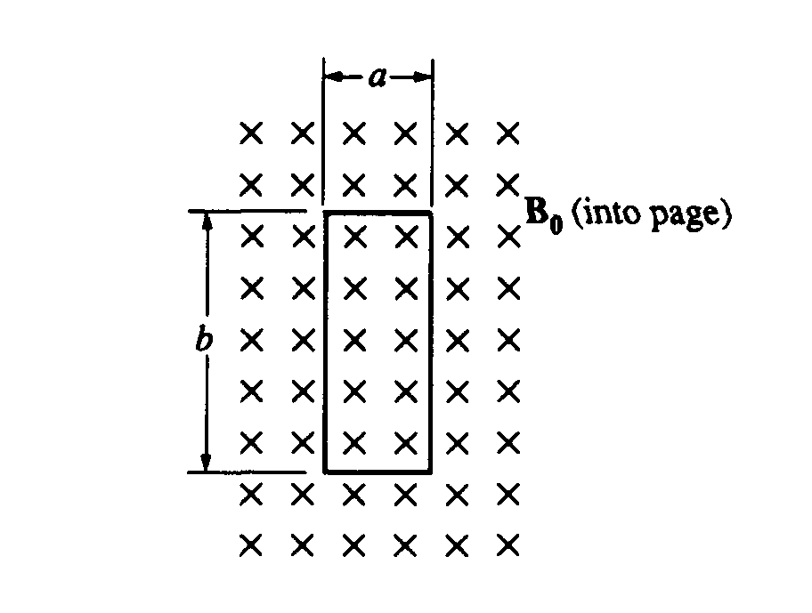  Faraday’s law, magnetic forces, induced I. |  | 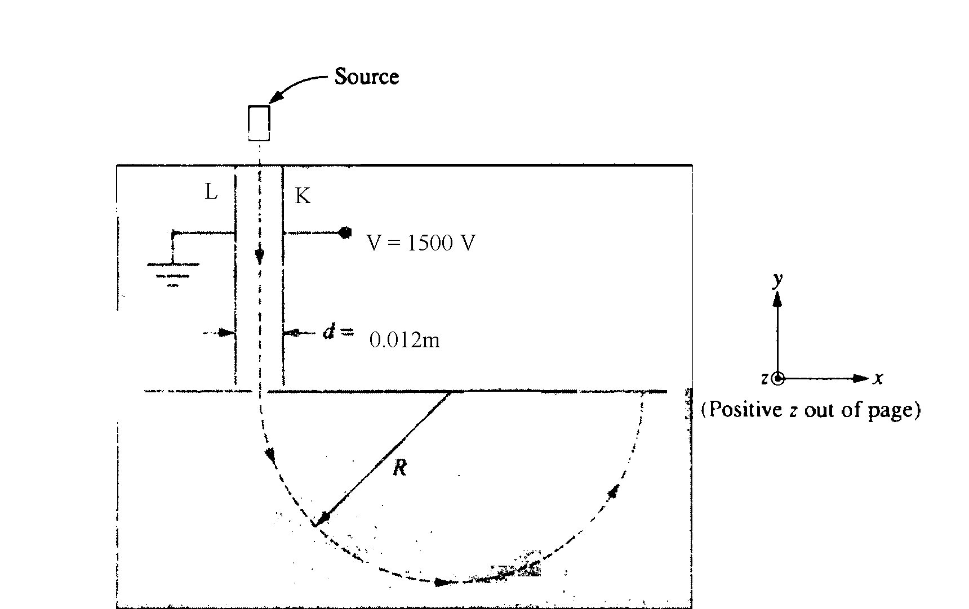  Mass Spectrometer.
1  9  9  4 | s  o  l  n |  | 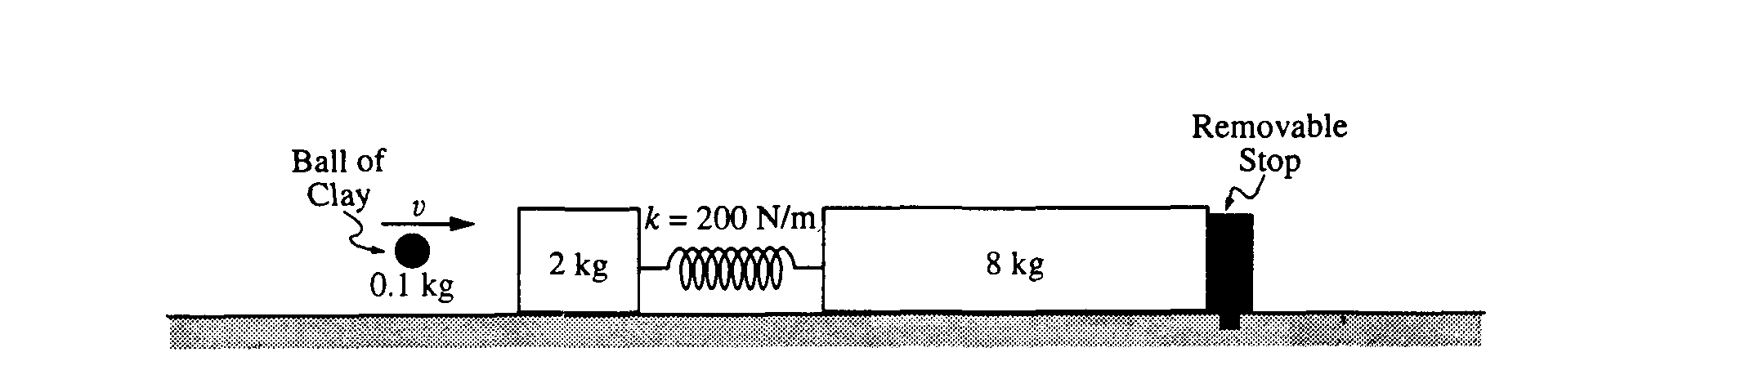  1994 - Cons of En and mom, spring |  |  | 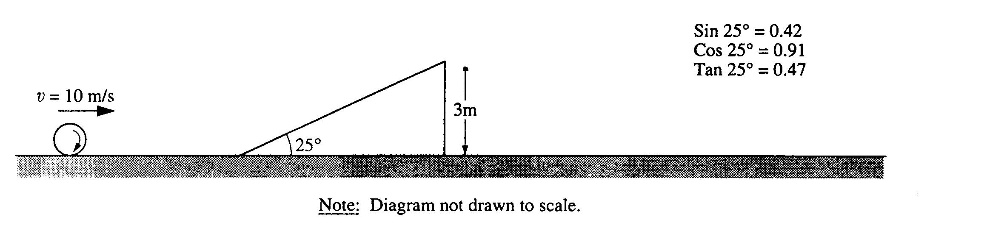  rolling w/o slipping, cons of energy on an incline. |  |  | 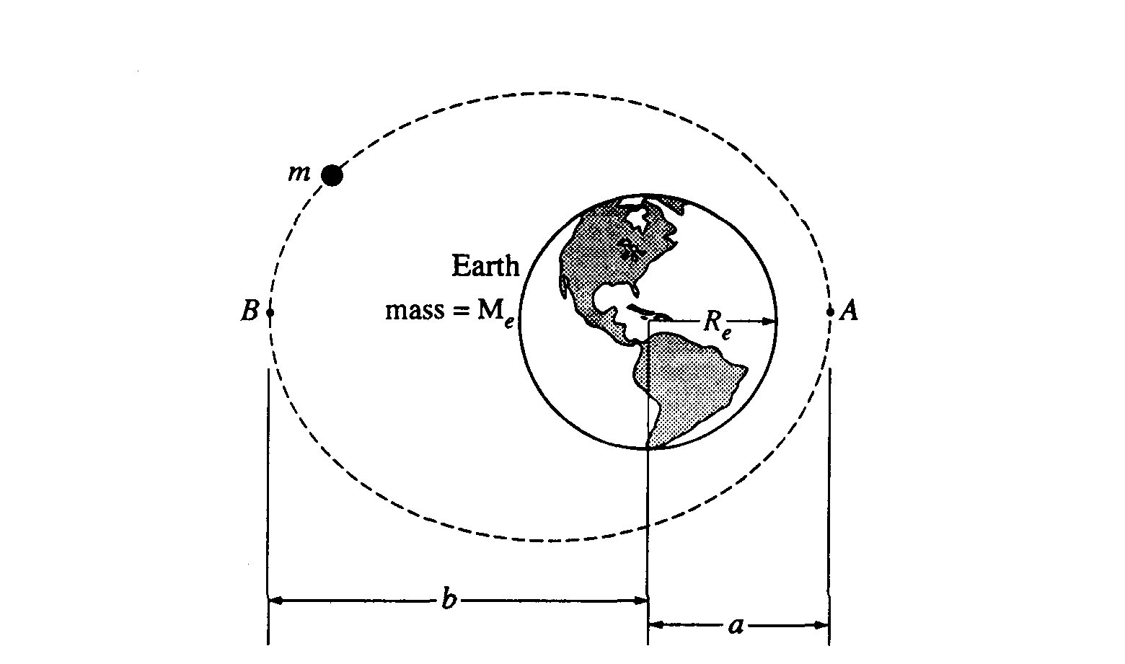  orbits, cons of energy and ang mom. |  |  | 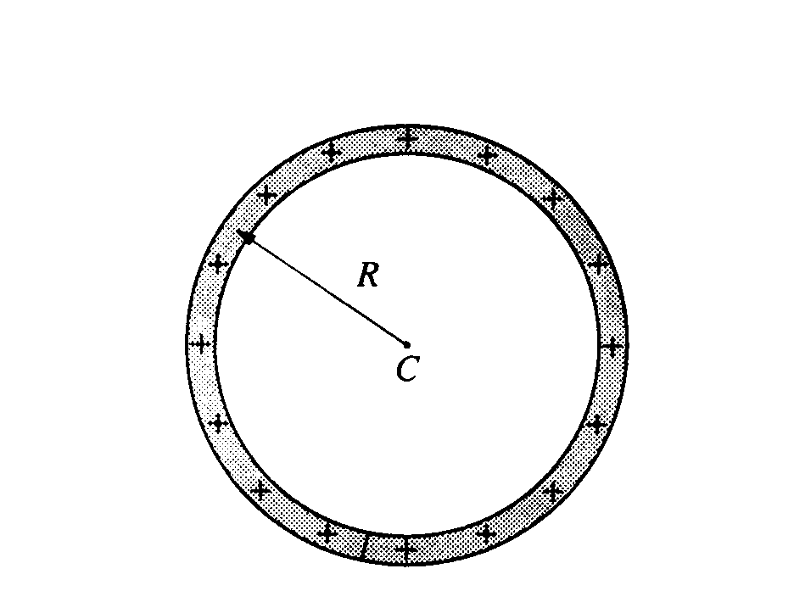  E field, potential - ring and part of ring. |  | 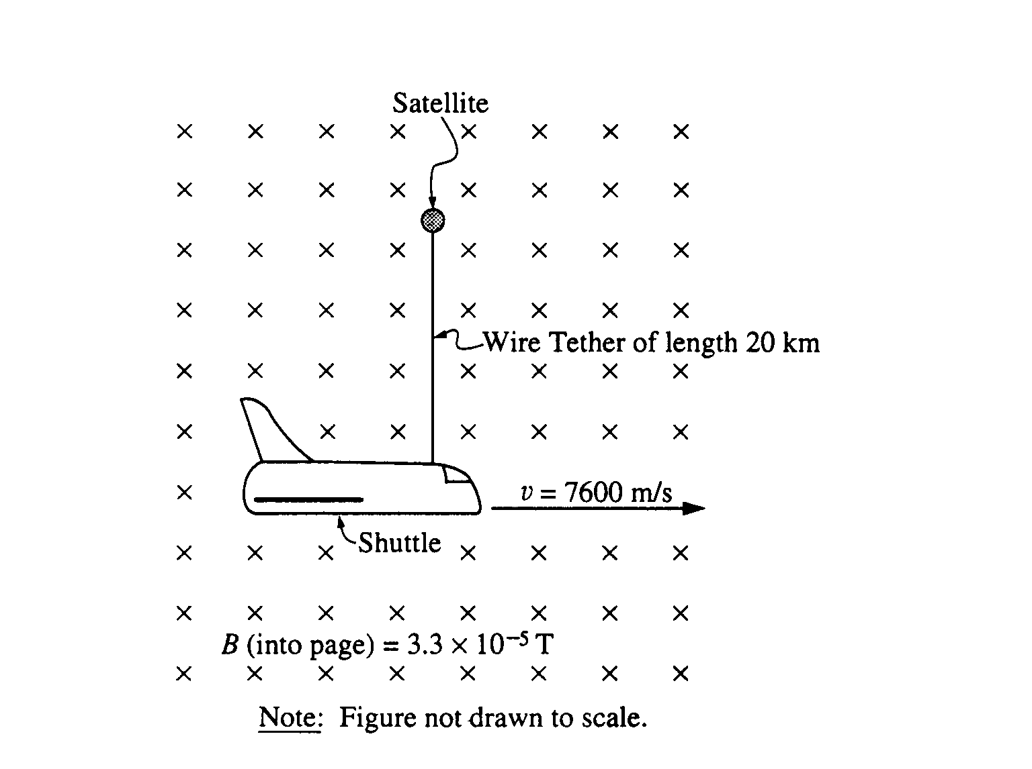  Motional Emf, energy conservation |  | 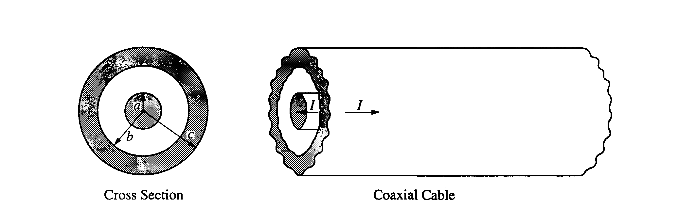  Coaxial cable, Amperes law for B field.
1  9  9  5 | s  o  l  n |  | 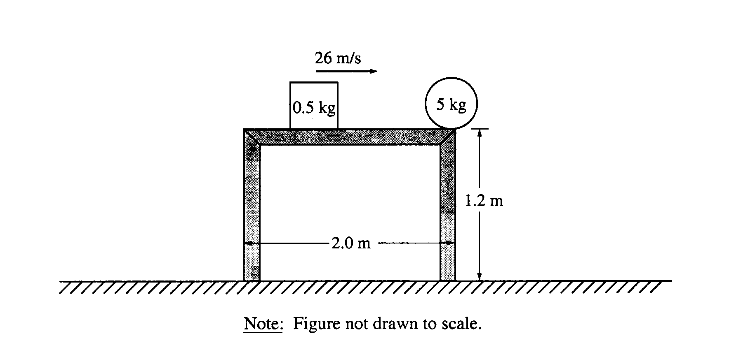  1995 - Impulse, momentum, projectile. |  |  | 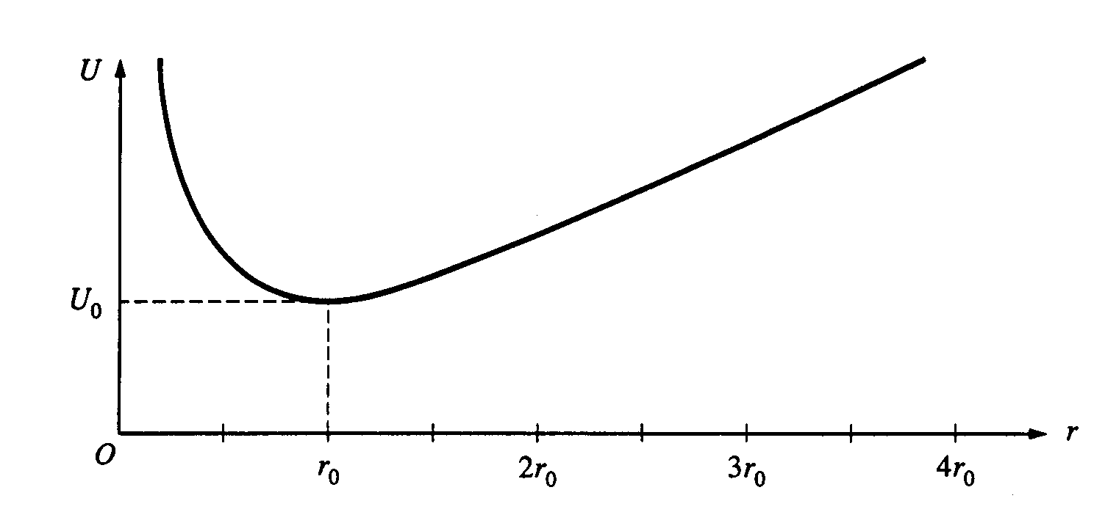  Potential energy function |  |  | 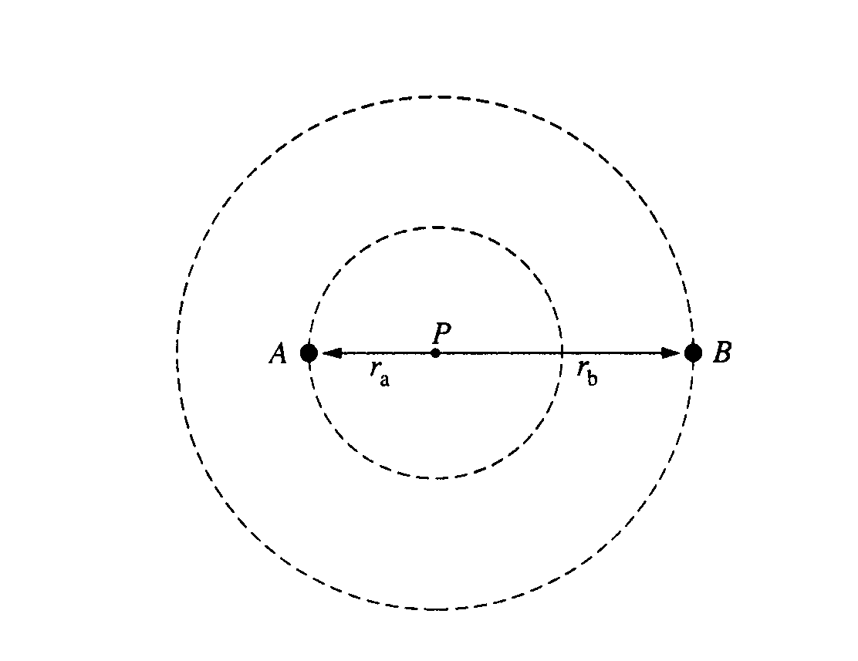  grav, orbits, ang momentum, moment of Inertia. |  |  | 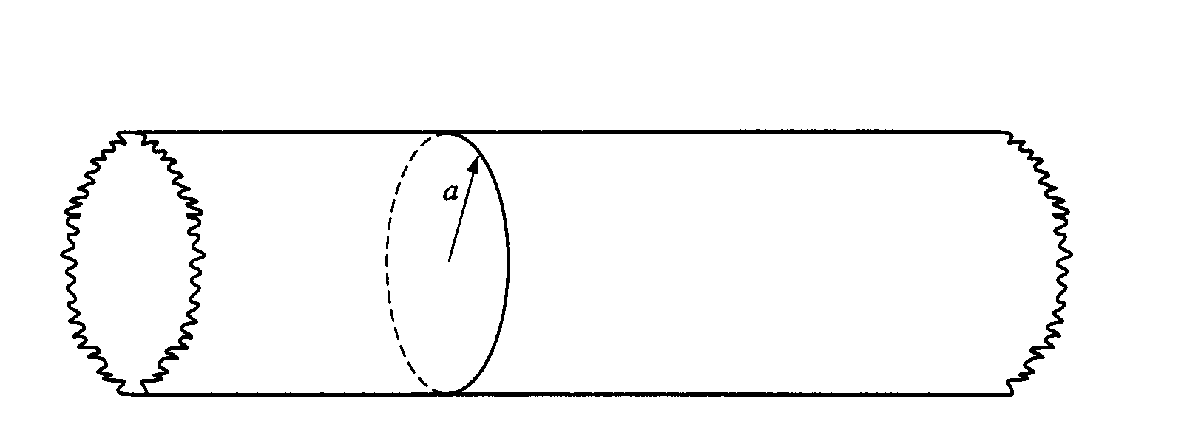  Nonconductor field and potential |  | 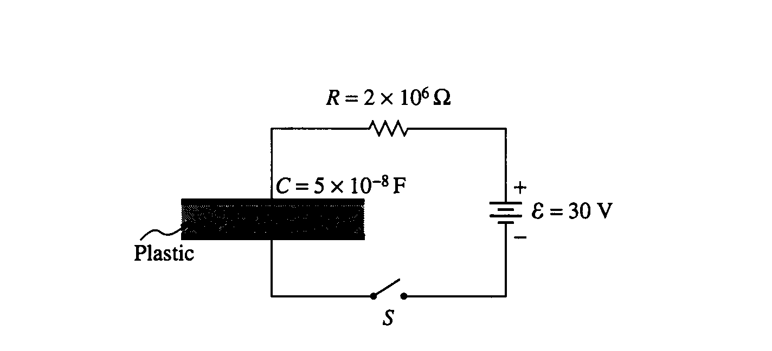  Capacitors, R-C Circuit |  | 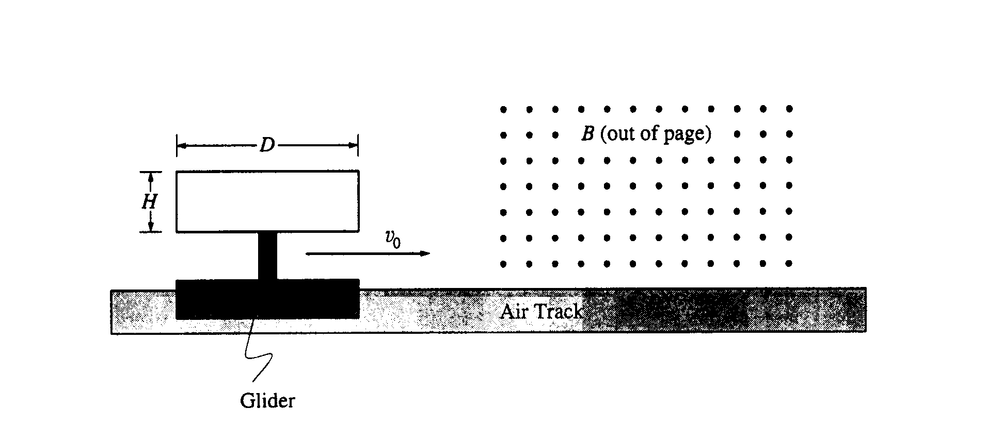  Air track - Motional Emf, Lenz’ Law
1  9  9  6 | s  o  l  n |  | 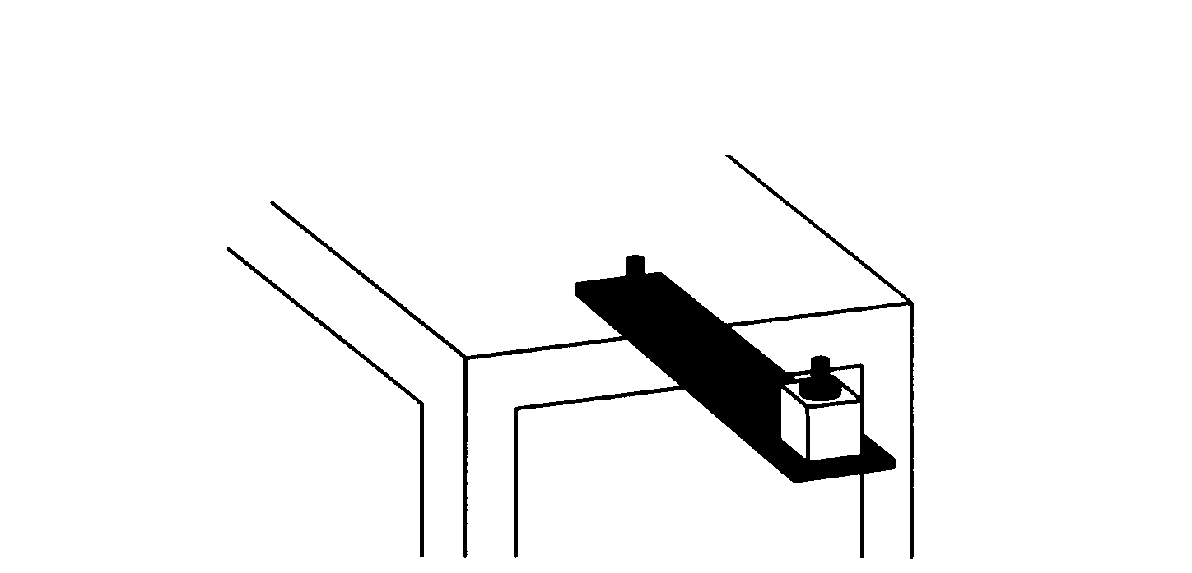  1996 - Lab question – vibrations  - Gravitation |  |  | 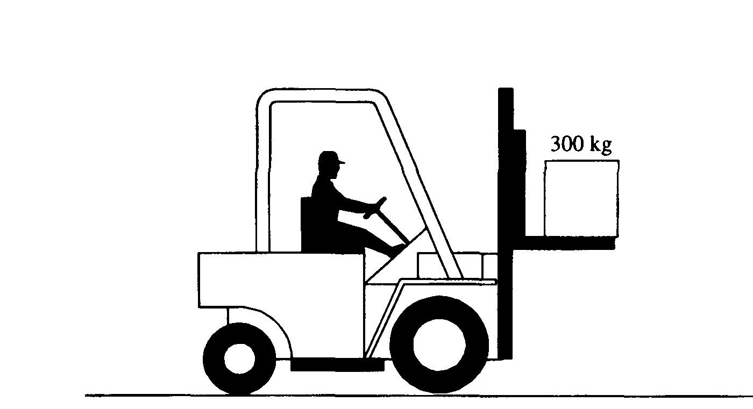  forklift - eqns of motion, friction |  |  | 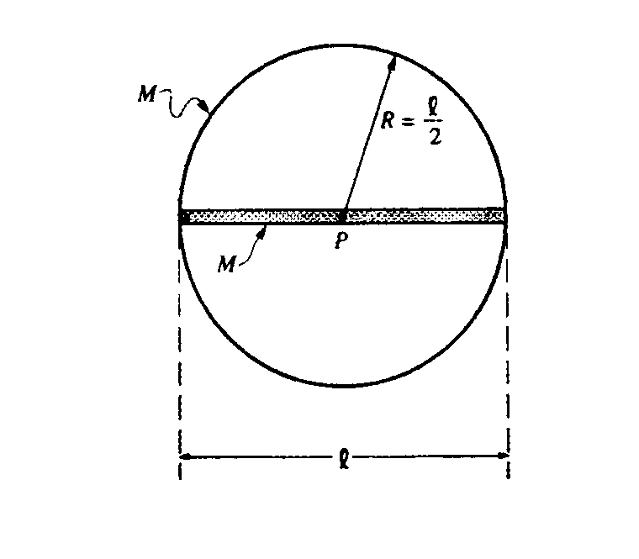  Mom of inertia of rod, hoop. Rota |  |  | 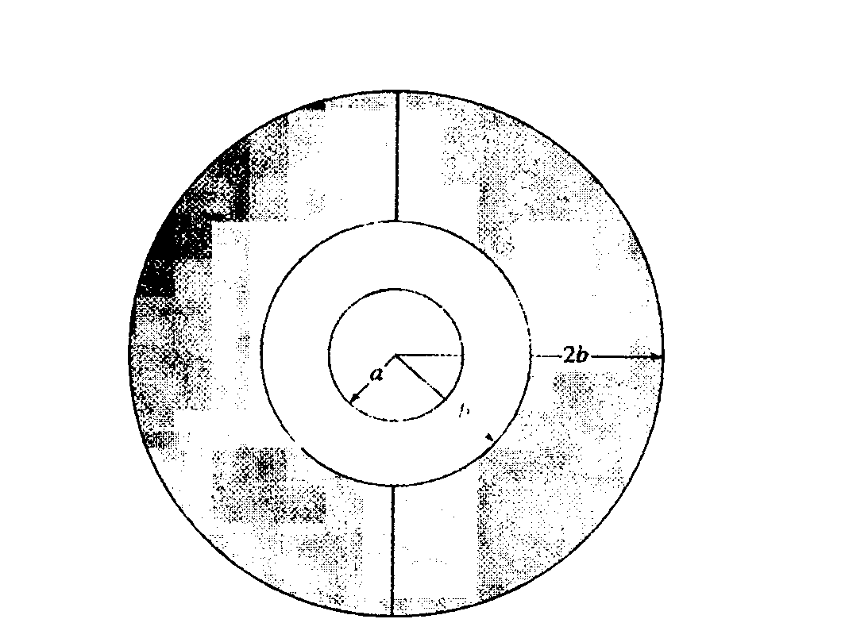  Concentric spheres - E field, V |  | 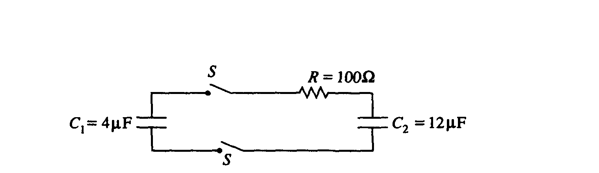  R-C Circuit |  | 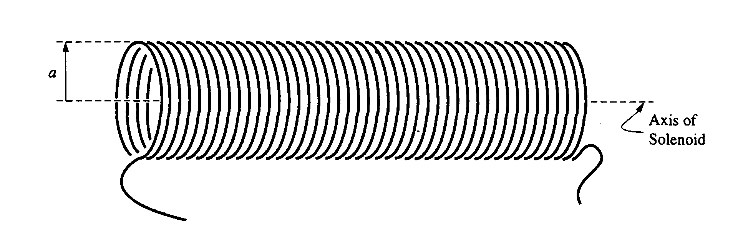  Faraday’s law, Solenoid
1  9  9  7 | s  o  l  n |  | 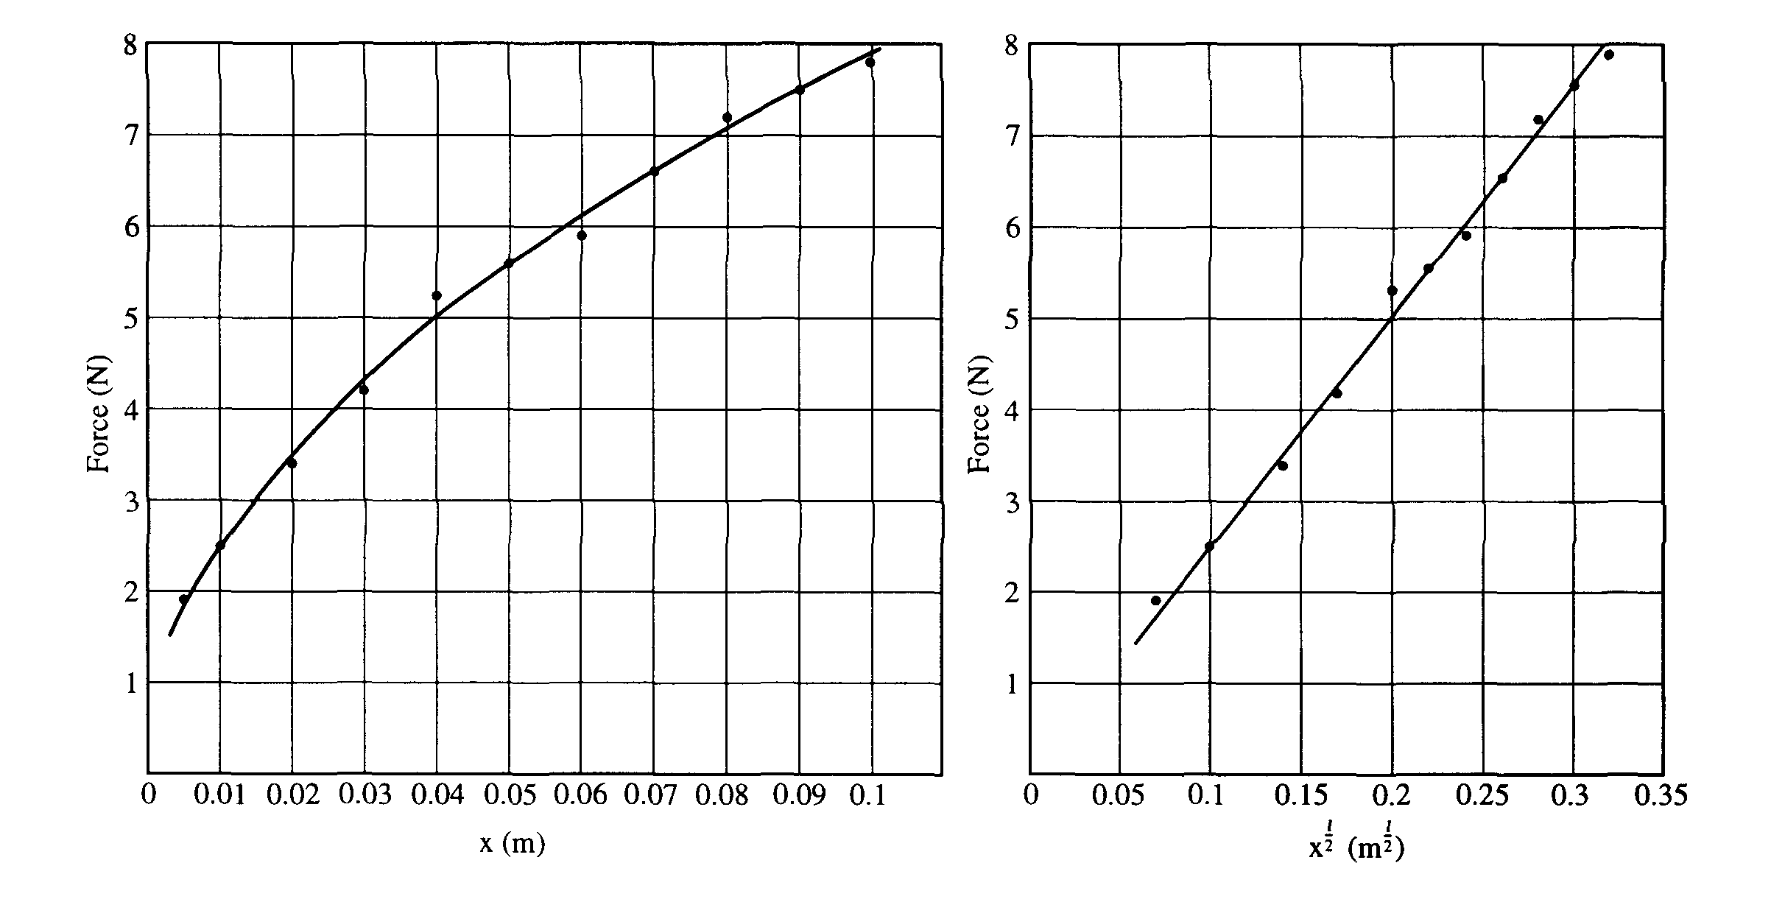  1997 - non-linear spring, lab question |  |  | 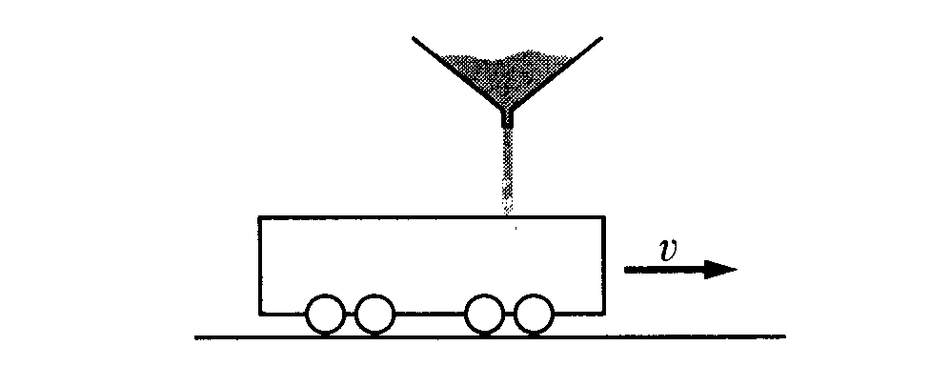  inelastic momentum - calculus treatment |  |  | 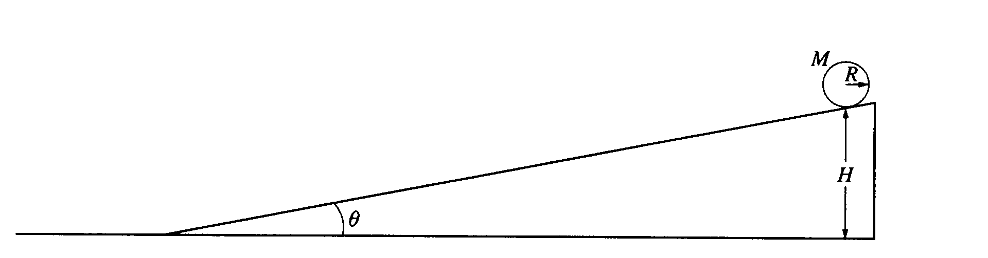  sphere on incline, acceleration, energy |  |  | 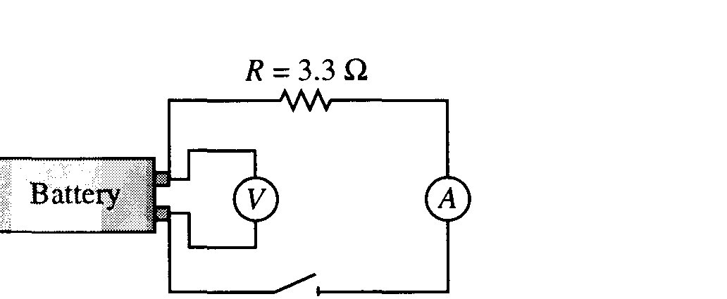  graphical analysis of circuit - experimental battery |  | 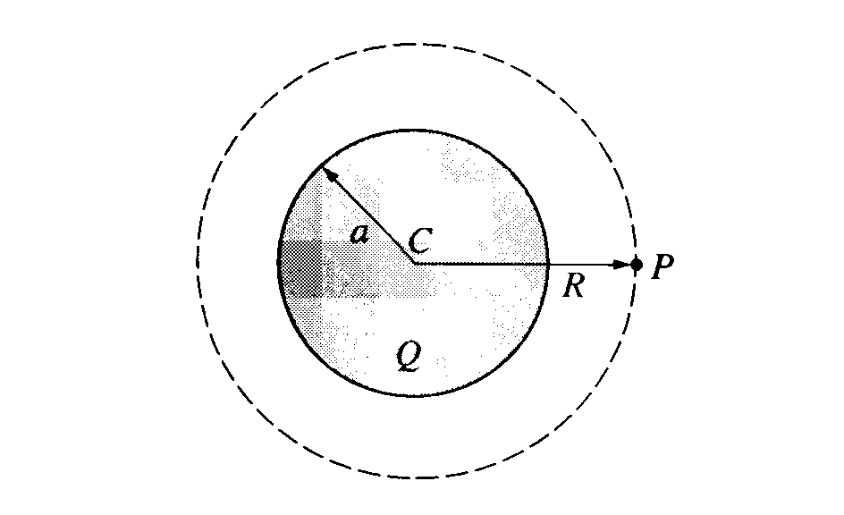  electric fields and forces - flux |  | 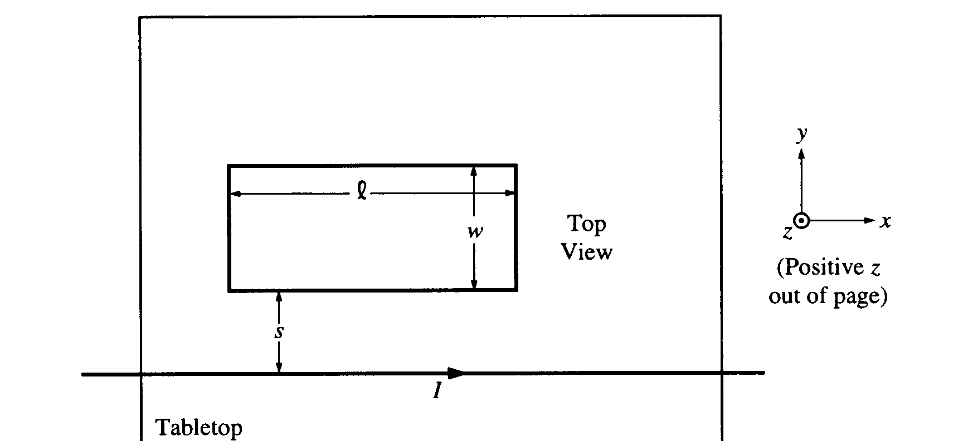  B field of long wire, flux, motional emf.
1  9  9  8 | s  o  l  n |  | 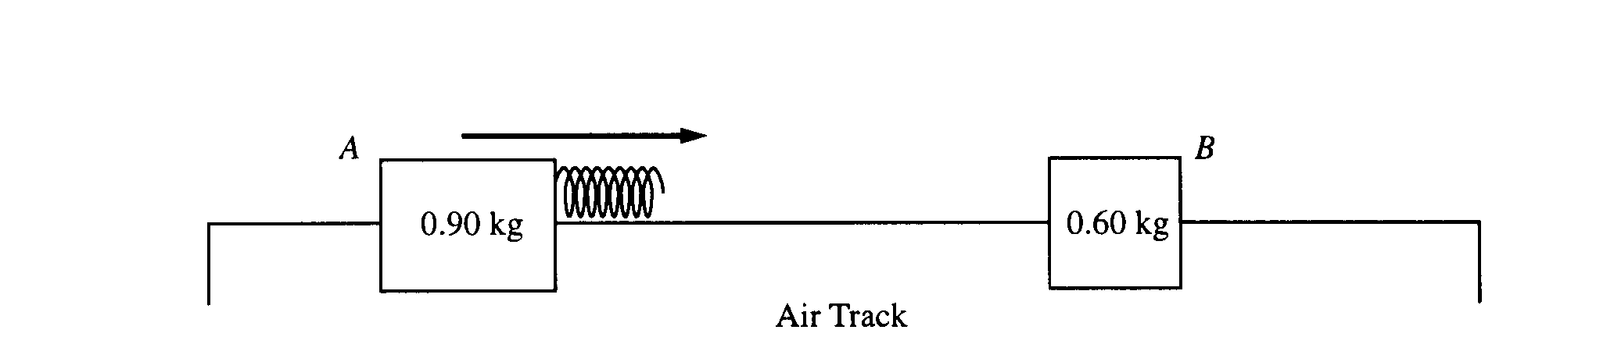  1998 - lab data for air track collision. |  |  | 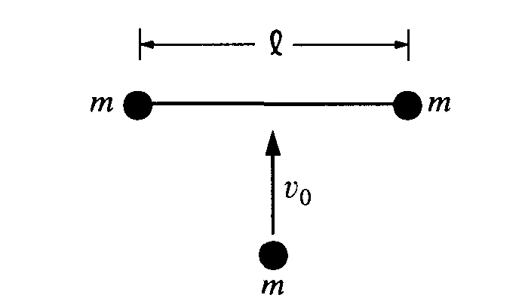  inelastic coll, linear and ang mom. C of M motion. |  |  | 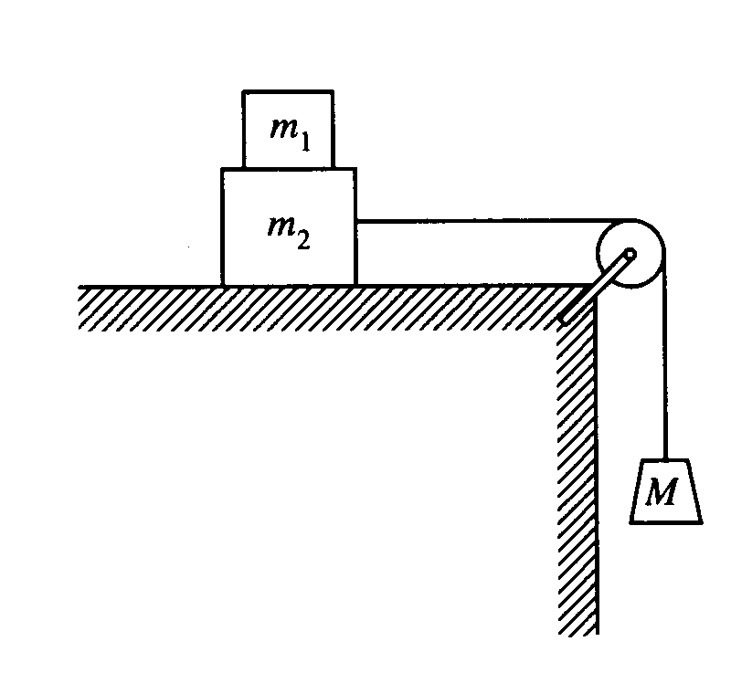  two body motion, friction, force diagrams |  |  | 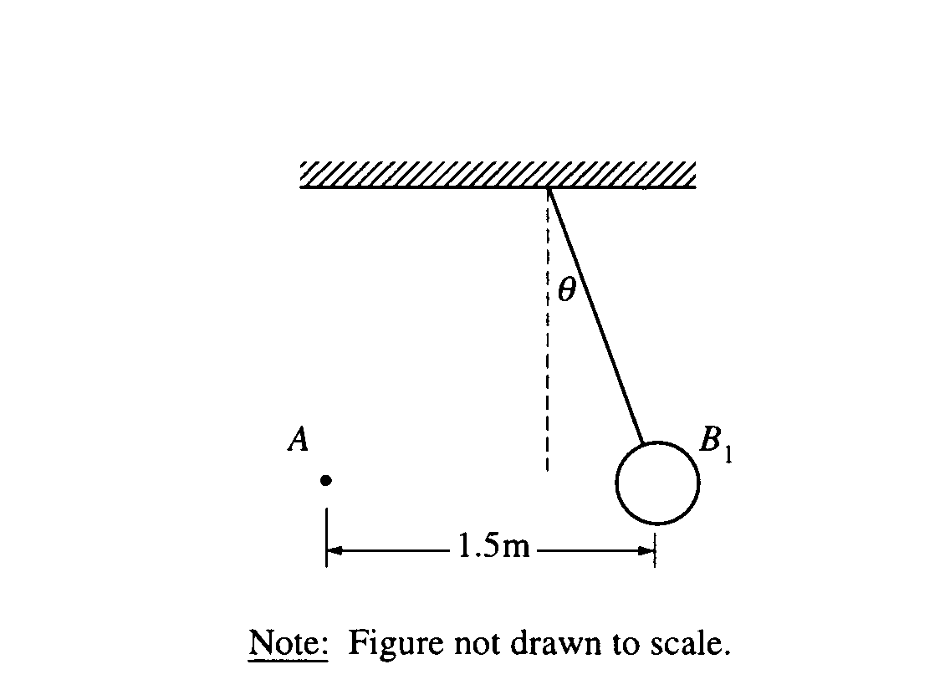  Coulomb, F=qE, forces. |  | 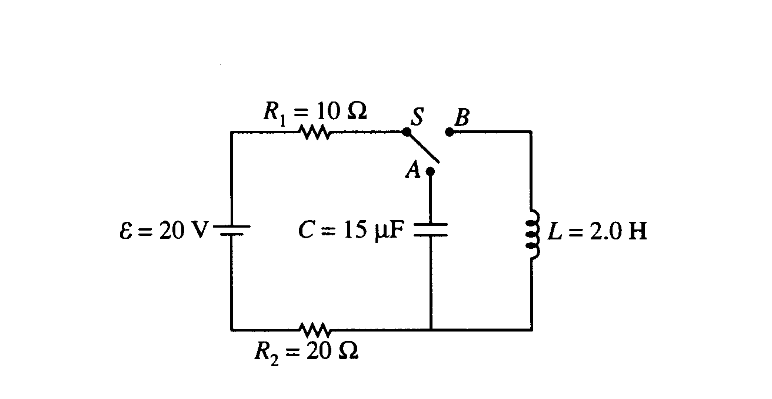  Circuit, R-C, R-L |  | 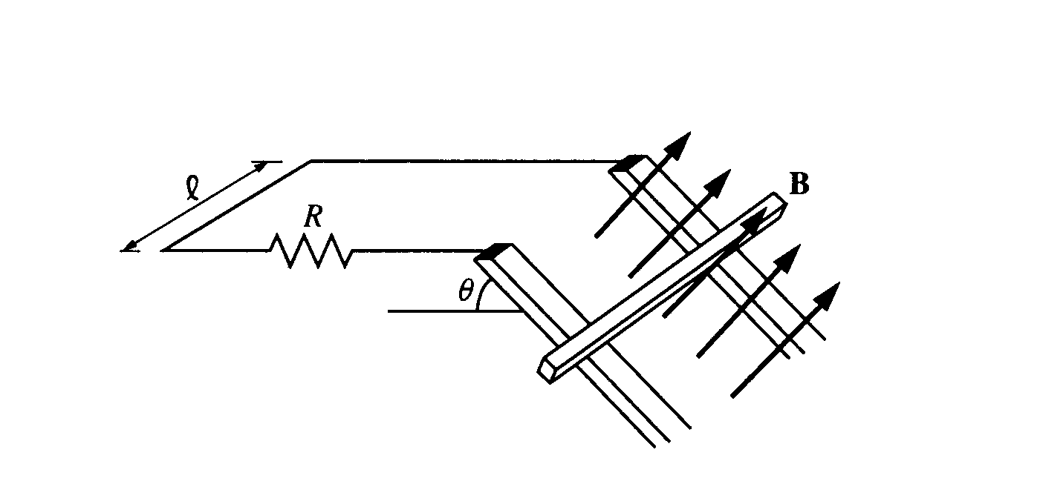  Motional Emf, bar sliding down incline, term vel.
1  9  9  9 | M  s  o  l  n  E | 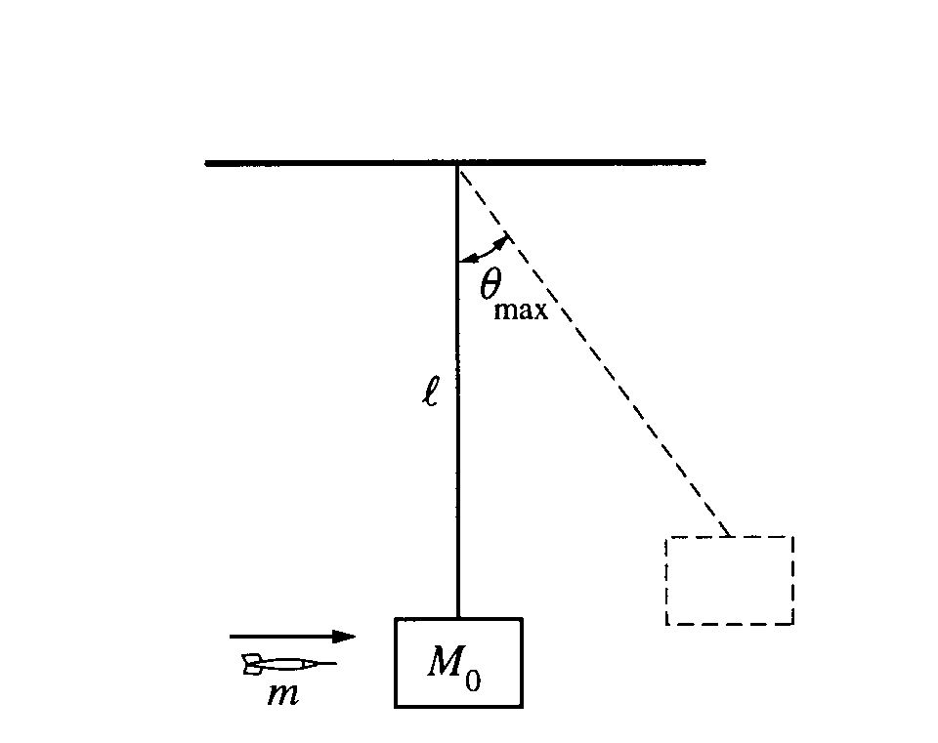  1999. Lab - ballistic pendulum |  | 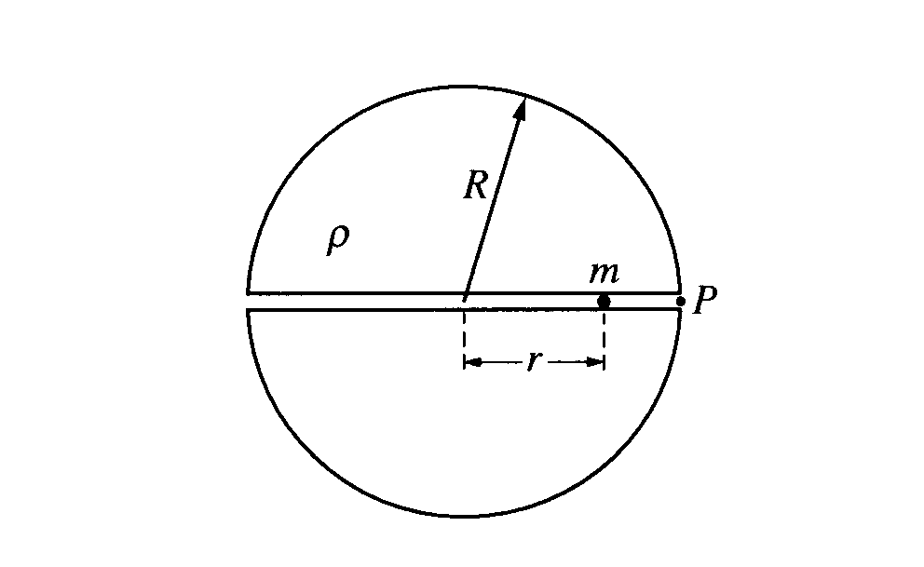  Hole through earth - SHM |  |  |  | 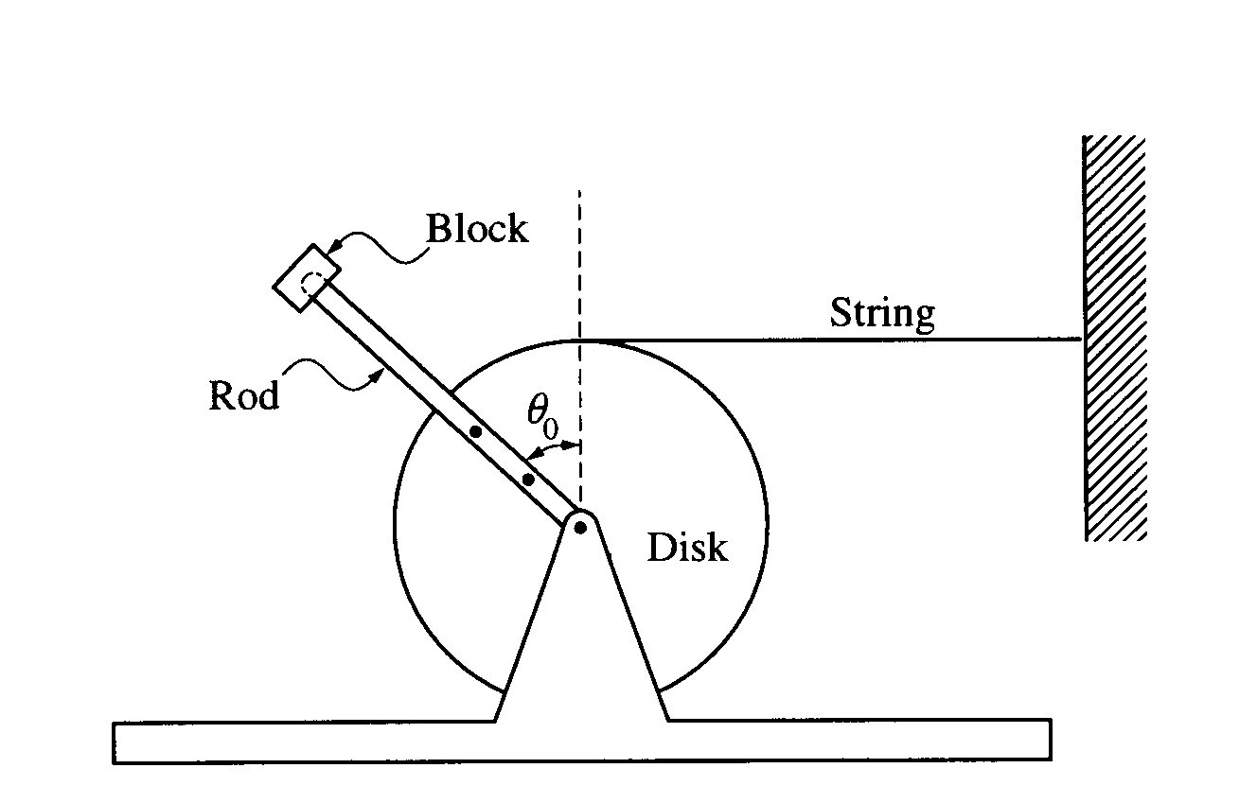  Rotational Eq, Energy |  | 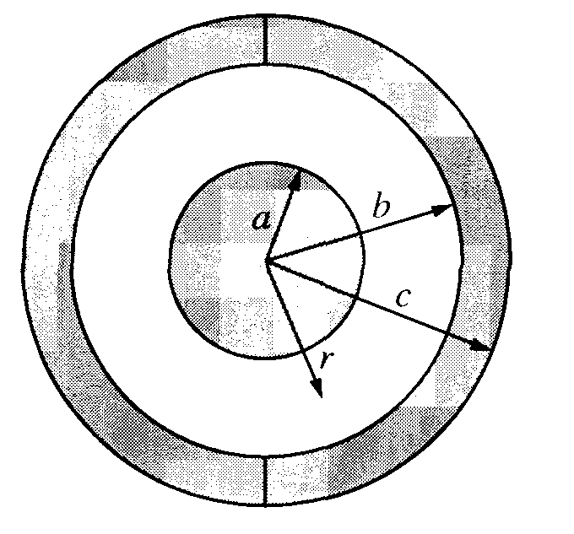  Spherical Capacitor |  |  |  | 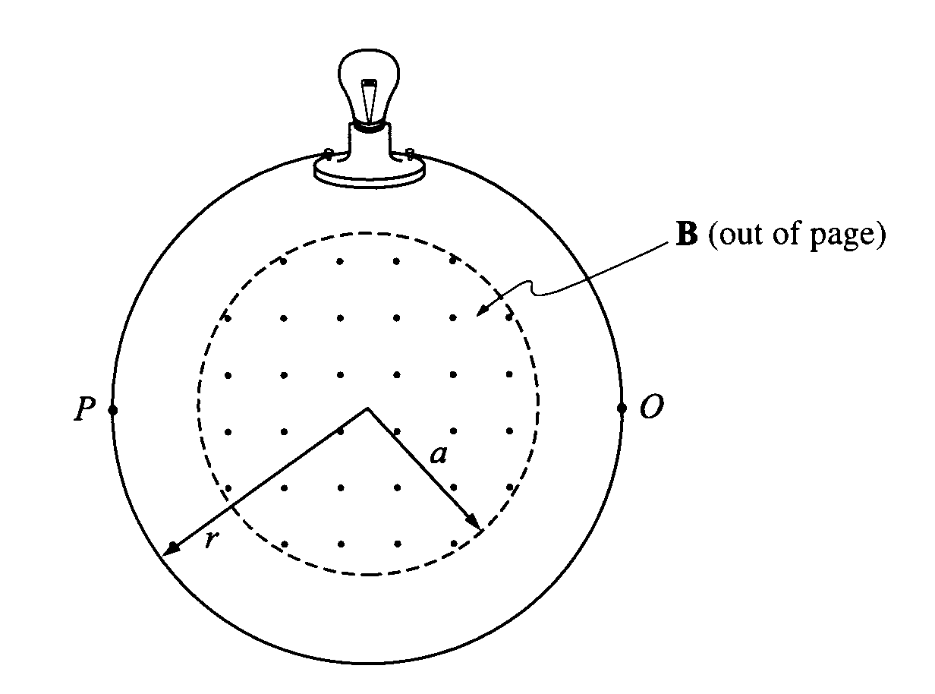  Induction | 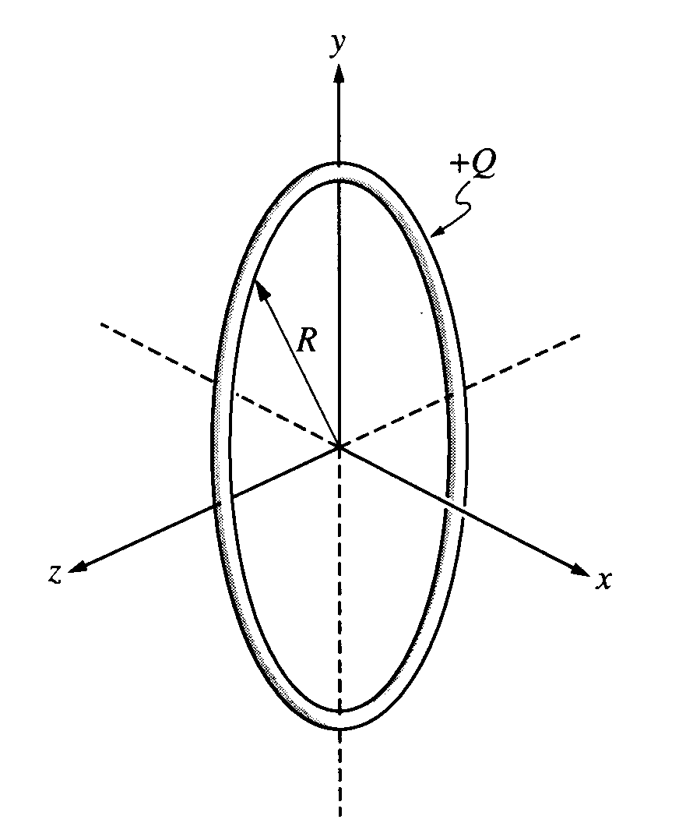  E field, potential, static ch
2  0  0  0 | M  s  o  l  n  E | 2000 Lab, pendulum, find g, elevator. |  | Ball falling thru resisting med, energy |  |  |  | F=ma, angular motion |  | Inductor - capacitor circuit |  |  |  | 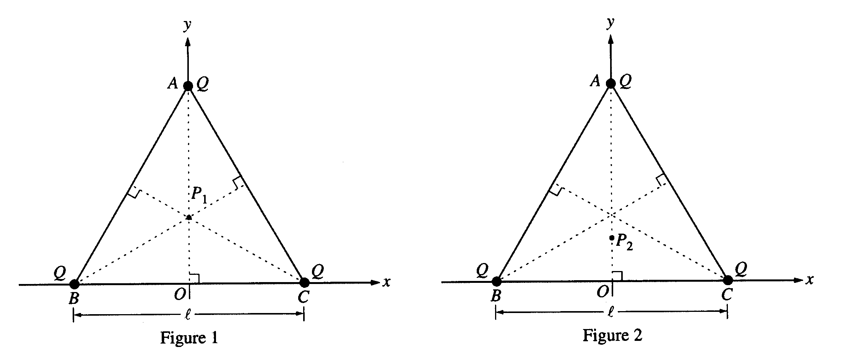  fields and potential | Gauss and Ampere
2  0  0  1 | M  s  o  l  n  E | 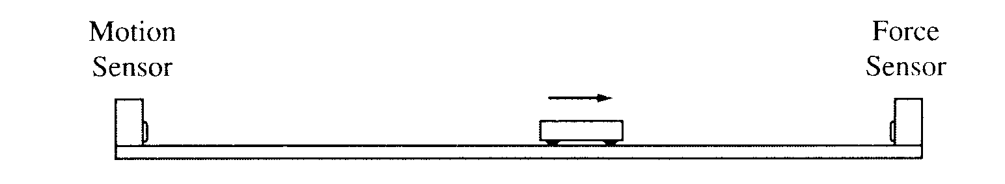  2001 - mass and force sensor - imp-momentum, acc |  | Gravity, satellite motion. |  |  |  | 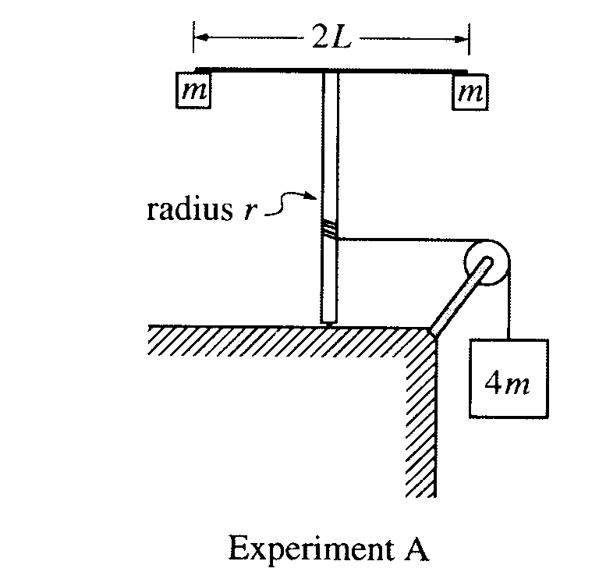  angular motion, rot inertia |  | 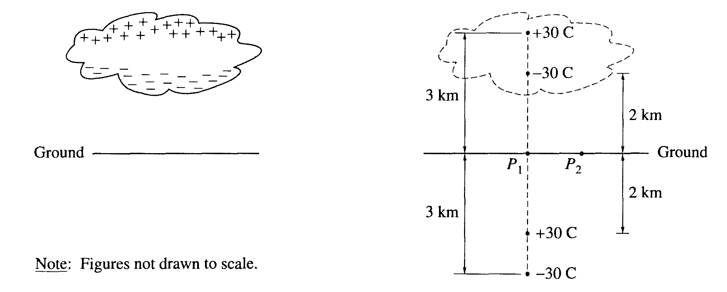  fields, potential, thunder |  |  |  | 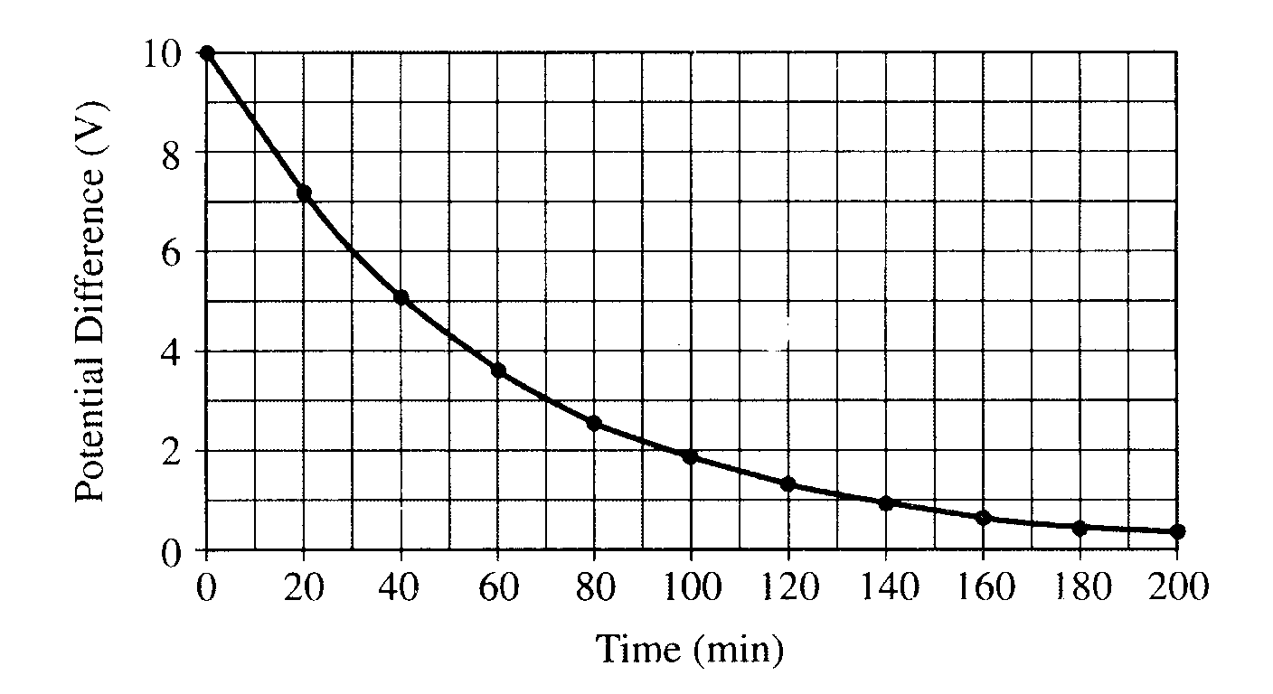  res of capacitors, dielect. | 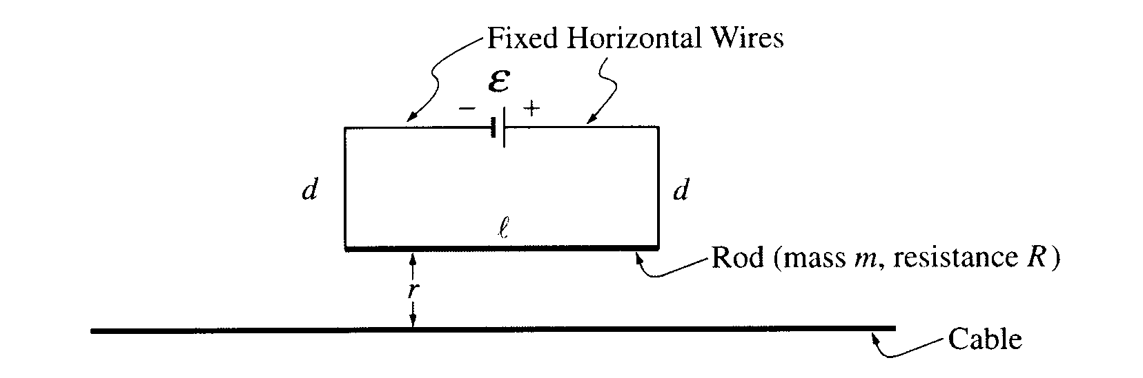  mag field of wire, forces.
2  0  0  2 | M  s  o  l  n  E | 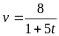  Collision and calculus kinematics |  | Energy: grav., rot., spring |  |  |  | U(x) = 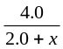,  Graphical U vs x, F=-dU/dx, exper. |  | Efield, potential, F, energy |  |  |  | RC circuit, exper. | 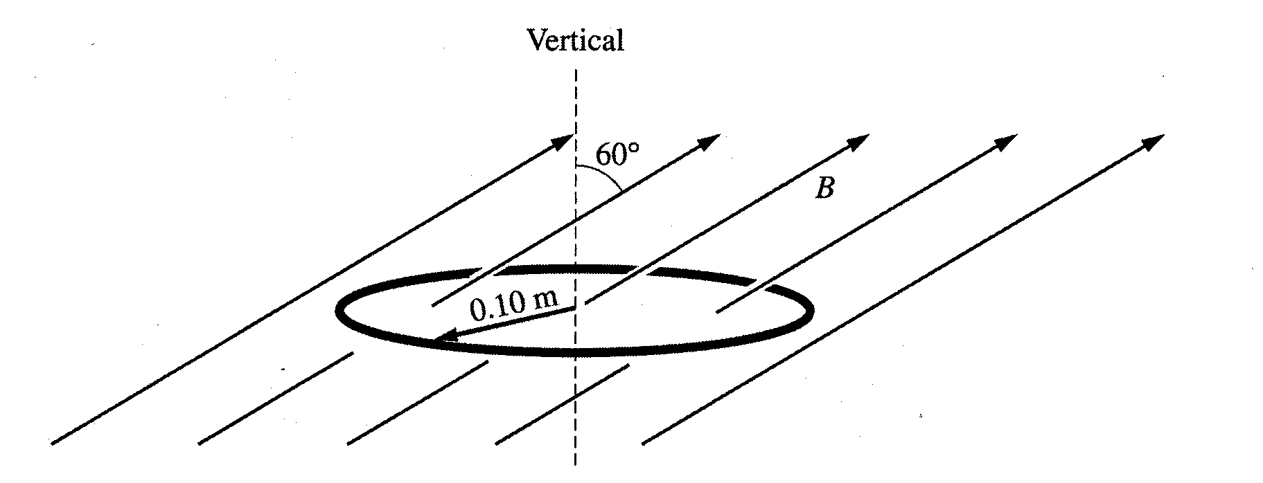  Flux and Induction, energy dissipated

